VNI West Environment Effects Statement Executive summary

Acknowledgement of Country
VicGrid proudly acknowledges the Traditional Owners of the lands on which VNI West is to be delivered, including those recognised through Native Title and those recognised by the State of Victoria as Registered Aboriginal Parties. We pay our respects to their Elders past and present.
VicGrid also acknowledges other First Peoples who maintain cultural connections, custodial responsibilities, and ongoing relationships to the lands and waters across the project area. We recognise their deep connection to Country and the significant role they play in caring for and managing land, water, natural and built landscapes, and in maintaining profound knowledge systems.
We remain committed to building genuine and enduring partnerships with First Peoples, grounded in respect, transparency, and cultural authority, to ensure that the planning and delivery of this project reflects their rights, culture, and connections to Country.

1. Introduction 4
2. Why is the Project needed? 5
2.1 Project objectives 7
3. Project benefits 8
3.1 Local and regional benefits 9
4. About the project 9
4.1 Project components 9
4.2 Construction 11
4.3 Operation 14
4.4 Decommissioning 15
5. Stakeholder engagement 15
5.1 Engaging with Traditional Owners 16
5.2 Community and landholder engagement 16
5.3 Landholder consultation 17
6. Planning for VNI West 17
6.1 Required Project approvals 17
6.2 EES process 18
6.3 EES assessment framework 20
7. Project development 23
7.1 Refining the Project to find the Proposed Easement 24
7.2 Undergrounding options 26
7.3 How engagement shaped the Project 27
8. Project impacts 29
8.1 Construction and operation 32
8.2 Decommissioning 54
8.3 Cumulative impacts 54
8.4 Proposed Easement options assessed in the EES 55
8.5 Key residual uncertainties 56
9. Environmental Management Framework 56
10. Next steps 59
10.1 Public review of the EES 59
10.2 Making a submission 60
10.3 The Inquiry and Advisory Committee process 60
10.4 Concluding the EES assessment process 61

Introduction
The Victoria to New South Wales Interconnector (VNI) West is a proposed new high-voltage electricity overhead transmission line extending from the Dinawan Substation in New South Wales (NSW) to Bulgana in Victoria, where it will connect to the proposed Western Renewables Link (WRL) project.
The Victorian component of VNI West (the Project) comprises approximately 240 km of new 500 kilovolt (kV) double-circuit transmission line and associated infrastructure, extending from Bulgana in the south, to the Murray River north of Kerang, where it would connect to the NSW component of VNI West.
Figure 1 provides an overview of the Project in its broader network context. The Project and its associated infrastructure would facilitate the transmission of renewable power from renewable energy zones (REZs) in both states and support the reliability and security of the Victoria-NSW electricity network.
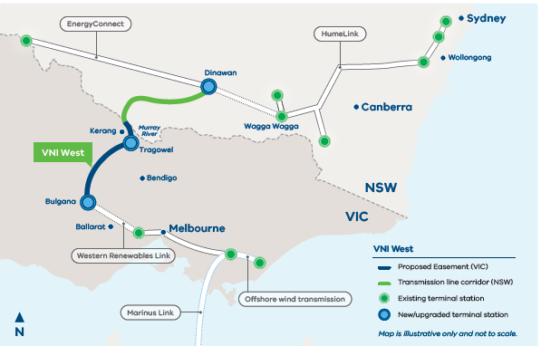
Figure 1: VNI West in the future transmission network

The power system in eastern Australia is undergoing fundamental, rapid and complex change as it transitions to a net zero emissions economy by 2050 or sooner, in line with the objectives of the Commonwealth and Victorian Governments. As coal-fired generators retire, new renewable generation – supported by transmission and storage and backed up by gas-powered generation where required – would supply reliable, lower-cost electricity to homes and businesses in Australia.
The opportunity to increase interconnection between Victoria and NSW was identified as part of the 2018 Integrated System Plan (ISP) (then referred to as SnowyLink). VNI West was identified as an actionable ISP project in the 2020 ISP, and this status has been retained in the 2022, 2024 and 2026 ISP updates.
The Project is also included on the Commonwealth’s National Renewable Energy Priority List, which identifies projects critical to supporting Australia’s transition to net zero emissions by 2050. The Commonwealth, State and Territory Governments developed the list collaboratively, and will provide coordinated support for regulatory planning and environmental approval processes for identified priority projects.
VicGrid was established by the Victorian Government in 2021 as an Administrative Office of the Department of Energy, Environment and Climate Action (DEECA), and from 1 November 2025 became a state business corporation. At that time, VicGrid assumed responsibility for transmission network planning in Victoria, including accountability for VNI West from the Australian Energy Market Operator’s Victorian Planning function.
VicGrid was established to support a more coordinated approach to the planning and development of Victoria’s transmission network, including earlier consideration of environmental, land-use, cultural and social matters and engagement with Traditional Owners, landholders, communities, government agencies and other stakeholders.
As a relatively new organisation, VicGrid does not have a historical track record of delivering completed major transmission projects in its own right. Its organisational capability has instead been established specifically to undertake Victoria’s transmission planning and development functions. This capability is supported by personnel and specialist advisers with experience in major infrastructure planning, environmental assessment, statutory approvals, engineering, stakeholder and community engagement and engagement with Traditional Owners.
Since 2021, VicGrid VNI West has placed emphasis on meaningful engagement with landholders, Traditional Owners, communities and other stakeholders. Feedback received through this engagement has informed planning and Project development, including the identification of opportunities to avoid or minimise potential impacts on environmental and community values. VicGrid’s organisational policies, governance arrangements and management frameworks establish requirements and expectations in relation to health and safety, environmental management, community and stakeholder engagement and engagement with Traditional Owners. These arrangements support the identification and management of environmental and social risks, compliance with statutory obligations and ongoing engagement with people and communities potentially affected by VicGrid’s activities.
The Project is proposed to be delivered by VicGrid VNI West Pty Ltd (VicGrid VNI West) with support from a Development Partner. Construction would be carried out by a Delivery Partner (also known as the Principal Contractor), and operation would be undertaken by the transmission network service provider (TNSP).
The Executive Summary provides an overview of the Project and the Environment Effects Statement (EES). The EES describes the existing environment, identifies the benefits and potential impacts during construction, operation and decommissioning, and proposes ways to avoid, minimise, manage and offset these impacts.
This summary should be read in conjunction with the EES.

Why is the Project needed?
Victoria has adopted renewable energy targets of 65% by 2030 and 95% by 2035, with economy-wide emissions reduction targets of 75 to 80% below 2005 levels by 2035 and net-zero emissions by 2045.
The Commonwealth government also has the objective of a net-zero emission economy by 2050 or sooner.
Meeting these goals will require a large-scale build-out of renewable generation and storage within a relatively short timeframe.
Victoria’s electricity system is undergoing a period of rapid transformation. Historically reliant on brown coal generation, primarily centred in the Latrobe Valley, the system is transitioning toward a lower-emissions, more diversified renewable energy mix. This shift is being driven by policy settings, technological advancements, and climate change commitments.
This transition is currently likely to result in all coal power stations retiring by 2050, and the majority in the next 10–15 years, with the resulting significant decrease in energy supply coinciding with an expected increased demand in energy. The electricity network must therefore adapt to increasing contributions from a mix of renewable generation, supported by energy storage, and stronger interconnections across the National Electricity Market (NEM).
A key driver of this transition is Victoria’s renewable energy targets of 65% by 2030 and 95% by 2035, alongside a broader commitment to net-zero emissions by 2045.
A defining feature of this transition is the development of new generation in areas with strong wind and solar resources. These new electricity sources are varied in location and often far from the generation hubs that the existing transmission network was built to support (see Figure 2). The current transmission network also has constraints, which are impeding any new and existing renewable energy developments.
Many renewable energy projects in Victoria have faced lengthy and costly connection processes, largely due to existing transmission infrastructure nearing capacity limits or being constrained by low system strength.
In response, the Australian Energy Market Operator’s (AEMO) ISP and the Victorian Transmission Plan (VTP) have identified immediate priority transmission upgrades to support both current and future renewable energy generation. This includes VNI West.
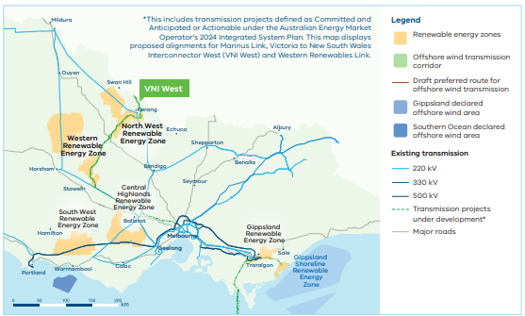
Figure 2: Renewable energy zones and strategic transmission development in Victoria
Timing is critical. With key facilities such as Yallourn and Loy Yang scheduled for closure over the coming years, there is an immediate need to secure Victoria’s energy system in the long term.
The Project is expected to be operational at a crucial point in the transition as coal-fired generation retires and renewable generation becomes increasingly dominant. Figure 3 summarises selected electricity system transition milestones relevant to the Project, including renewable electricity targets, coal-fired generation retirement assumptions and the Project’s intended delivery timing.
In this context, transmission infrastructure is a necessary part of the future electricity system. It enables new generation to connect, supports the transfer of electricity between regions, and helps maintain the security and reliability of supply as the generation mix changes.
In 2018 AEMO’s ISP confirmed the need for new interconnector transmission lines to maintain the flexibility and security between the electricity networks in NSW and Victoria and to enable more capacity for renewable energy connections into the NEM. Following this, AEMO commenced a Regulatory Investment Test for Transmission (RIT-T) process, an economic cost-benefit test to establish the business case for the Project and to confirm that the investment, ultimately funded by consumers, would deliver positive market benefits to consumers.
Through the RIT-T process (see EES Chapter 3 Project development and alternatives), multiple corridors were identified and considered for the infrastructure, with the preferred option – considering cost-benefit analyses, environmental and cultural constraints, and undergrounding concerns – ultimately being identified as the Project.
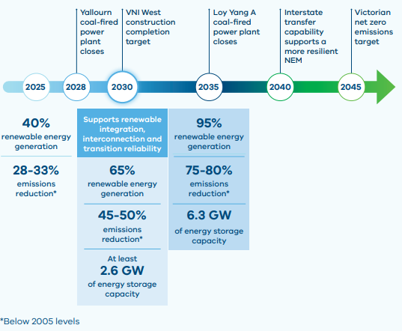
Figure 3: Selected electricity system transition milestones relevant to VNI West (adapted from VTP 2025)

Project objectives
VNI West is an important part of the transmission development needed to support renewable integration, strengthen interconnection and maintain system reliability.
The Project was developed to meet the following objectives:
- Facilitate the transmission of renewable electricity generated in renewable energy zones in Victoria and New South Wales
- Strengthen transfer capability between Victoria and New South Wales within the National Electricity Market
- Maintain the security and reliability of the Victoria–New South Wales electricity network as coal-fired generation progressively retires

Project benefits
Transmission constraints have been identified as a major obstacle to further renewable energy development in western and north-western Victoria. The Project is intended to address that constraint by increasing transmission capacity and improving access to renewable generation in western Victoria and southern NSW.
With the Project in place, Victoria would be better placed to move away from coal, with the resulting supply gap able to be met through renewable imports and new variable renewable energy capacity. This not only has direct benefits such as facilitating existing and future renewable generation but has broader benefits by contributing to the economic activity in Victoria, as well as supporting social and environmental outcomes.
A key benefit of the Project is its role in supporting emissions reduction outcomes, in line with Victoria’s renewable energy and emission targets.
The project will carry clean, low-cost renewable power from REZs in New South Wales and Victoria, harnessing more than 3.4 GW (gigawatts) of new renewable generation in the North West and the Western Victorian REZs. This will add 1.9 GW of export capacity from Victoria to New South Wales and 1.7 GW of import capacity from New South Wales to Victoria.
Once in operation, the Project is expected to avoid approximately 10.98 million tonnes of CO2 -e emissions in Victoria and reduce fossil fuel-based electricity generation by around 18 terawatt hours. In doing so, it would contribute to both decarbonisation and improved system reliability.
More broadly, the Project is expected to strengthen investor confidence in renewable energy development in western Victoria and surrounding regions. By improving network capacity and performance, it would facilitate the orderly development of REZs and support the efficient utilisation of Victoria’s renewable energy resources over time.
- 1.7 GW of import capacity from New South Wales to Victoria
- 1.9 GW of export capacity from Victoria to New South Wales
- Up to 700 construction workers across the 3.5-year construction period
- $1.3 billion economic benefit (direct and indirect) in Victoria
- $2.9 billion total economic impact (GDP) to Australia
- Enables more than 3.4 GW of renewable generation in the Murray River and Western Victorian Renewable Energy Zones
- Supports local business, education and employment opportunities
- Supports local jobs and activity in industries supporting the renewable energy sector
- Avoids about 10.98 million tonnes of CO2 -e emissions in Victoria
- Reducing fossil fuel electricity generation by about 18,000 GWh
- A positive legacy and contribution through the Community Energy Fund and social procurement

3.1 Local and regional benefits
The Project is expected to drive economic activity and employment across Victoria. The labour force proposed for the Project foresees a maximum construction workforce of up to 700 full-time jobs during construction, boosting the local and regional economy. This investment in the regional economy during construction is modelled to generate up to $2.9 billion in total gross domestic product impact across Australia, including approximately $1.3 billion within Victoria. The cumulative market benefits exceeding $4 billion in present value terms primarily reflect avoided or deferred investment in generation and storage, as well as reduced fuel costs.
The Project may also contribute to broader community outcomes through investment in initiatives intended to support social, economic and environmental uplift for affected communities.

About the project
VNI West will involve the construction and operation of a new 500 kV overhead double-circuit transmission line, running from the Dinawan Substation in NSW to Bulgana in Victoria, where it would connect to the proposed Western Renewables Link project.
The Victorian component – the Project – would be approximately 240 km long, and span four local government areas (LGAs), namely, the Northern Grampians, Buloke, Loddon and Gannawarra.
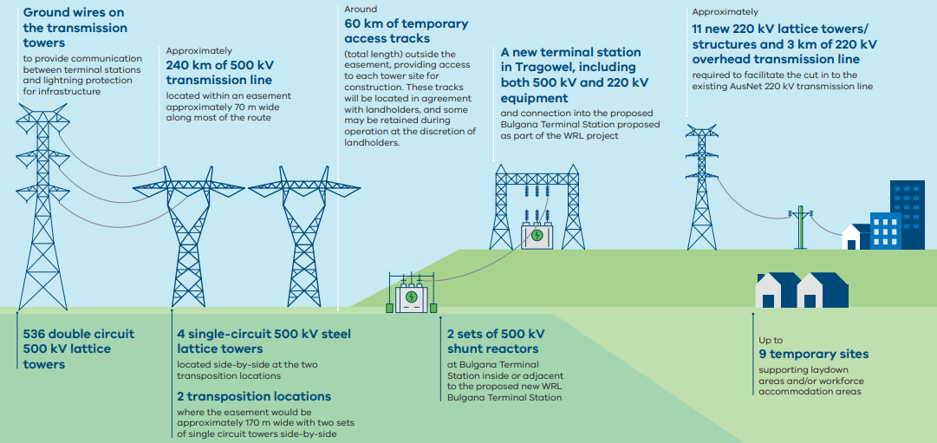
Figure 4: Key Project components

Project components
The key components of the Project are:
500 kV transmission line
The development, construction, and operation of approximately 240 km of new 500 kV double-circuit overhead transmission line between the proposed new Bulgana Terminal Station (WRL’s proposed project), Tragowel Terminal Station and the Murray River, where it will become the responsibility of Transgrid in NSW.
The new 500 kV overhead double-circuit line would most likely be configured as 536 steel lattice towers with expected tower distances to be in the order of 400 m, and tower height generally between 60 and 80 m.
Two transposition locations, approximately 900 m long and 170 m wide, will be required for the 500 kV transmission line (allowing for improved efficiency over its 240 km). Transposition locations have been allowed for near Swanwater and Glenloth. At these locations it is proposed that two smaller, 500 kV single-circuit towers be placed side by side to facilitate the transposition.
Tragowel Terminal Station
The development, construction, and operation of a new terminal station in Tragowel, including both 500 kV and 220 kV equipment.
220 kV transmission towers
The construction of eleven 220 kV towers/structures, including single-circuit and double-circuit configurations, required to cut into the existing AusNet 220 kV transmission line.
220 kV transmission line modifications
Modification of the existing 220 kV Bendigo to Kerang transmission line (AusNet’s asset) near the proposed Tragowel Terminal Station, to facilitate the interface to the 220 kV switchyard of the new terminal station.
Bulgana Reactor Station work
Development of two new 500 kV line shunt reactors to connect into the proposed new WRL Bulgana Terminal Station. The new 500 kV line shunt reactors would be established within, or adjacent to, the proposed WRL Bulgana Terminal Station. Interface works would also be required with the WRL Bulgana Terminal Station, connecting the new 500 kV double-circuit overhead transmission lines into the proposed WRL.
Accommodation facilities and laydown areas
Development of up to nine temporary workforce accommodation and/or laydown areas spaced along the 240 km length.
Transgrid interface works
VNI West Project would construct the final Victorian tower. Transgrid would be responsible for the Murray River crossing and the installation of all transmission line infrastructure from NSW. Interface works required on final 500 kV tower on the Victorian side of the Murray River.
For more detail on Project components and construction, operation and decommissioning activities, refer to Chapter 4: Project description.
All Project components are proposed within a transmission easement, a corridor generally 70 m in width. This Proposed Easement is the culmination of several years of regulatory processes and refinement. The refinement process involved:
Area of Investigation
Identified in AEMO’s Project Assessment Draft Report (July 2022), which defined an area in northwest Victoria between Bulgana in Victoria and Dinawan in NSW to deliver the Project.
Area of Interest
An area approximately 5–50 km in width, stretching from central northwest Victoria to the Murray River.
Draft Corridor
The Draft Corridor, approximately 2 km wide, was selected from within the Area of Interest following feedback from Traditional Owners, landholders, community members, government agencies, stakeholders and data from technical and environmental studies on the least constrained corridor.
Proposed Easement
The Proposed Easement was identified within, or near to, the Draft Corridor and is the proposed location of the 500 kV transmission line infrastructure. The Proposed Easement is 70 m wide, except at two transposition locations where it is approximately 170 m wide.

Construction
The Project is scheduled to start construction in late 2027 and be completed by late 2030 as shown in Figure 5.
Construction of the Project would be completed in packages. These packages may start and stop at various stages of the construction schedule and occur at the same time. Construction of the Project will take up to 3.5 years and it is expected that there would be multiple construction teams working simultaneously in different parts of the easement.
A high-level estimate of the construction schedule for key components is as follows:
- Tragowel Terminal Station (KXTS) – 36 months
- WRL Bulgana Terminal Station shunt reactors and interface work – 30 months
- 500 kV double-circuit overhead transmission line – 36 months
- 220 kV single-circuit overhead transmission line – 23 months
Construction working hours may vary across construction packages but it is anticipated that construction of the Tragowel Terminal Station, Bulgana Reactor Station and transmission line infrastructure would typically be undertaken during normal working hours being:
- Monday to Friday: 7 am - 6 pm
- Monday to Friday: 7 am - 6 pm
Additional low-noise, managed impact or unavoidable works may occur:
- Saturday: 1 pm - 6 pm
- Sunday: 7 am - 6 pm
The following section provides an overview of the key construction activities for the overhead transmission line infrastructure, terminal stations, and workforce accommodation and laydown areas.
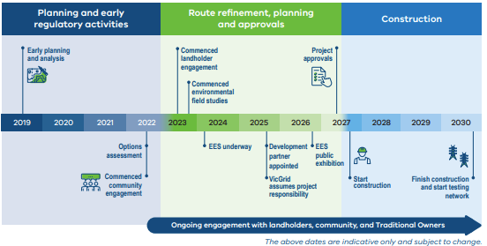
Figure 5: Proposed Project timeline

4.2.1 Transmission line infrastructure
The construction methodology for the proposed transmission line would generally include:
Site and access establishment, including:
- Installation of environmental controls, fencing and the placement of workforce amenities
- Removal of vegetation where necessary
- If necessary, relocation or protection of services, and improvement works to any public roads
- Establishment of access tracks to access the easement and relevant hardstand areas around the proposed tower locations
Construction of the transmission line towers, including:
- Construction of tower foundations
- Tower assembly and erection
- Conductor stringing between towers, anticipated to be by a combination of helicopter, tension or drone stringing methodologies
Each stage of construction is not intended to be done in a continuous sequence, and there may be periods of inactivity ranging from one week to several months. Further information on the construction of transmission line infrastructure is provided in EES Chapter 4: Project description.

4.2.2 Terminal stations
For the new Tragowel Terminal Station, the construction methodology would generally include:
Site and access establishment, including:
- Installation of environmental controls, fencing and the placement of workforce amenities
- Removal of vegetation where necessary
- Establishment of overhead or underground power to supply the construction site (i.e. for the provision of general site services, such as water, sewer, communications, power)
- Bulk earthwork to form the terminal station bench, access roads, drainage, and oil containment structures
Construction of the terminal station, including:
- Construction of terminal station foundations, structures and primary equipment
Post construction activities, including:
- Testing and commissioning of the terminal station infrastructure
- Demobilisation and rehabilitation of construction facilities
Construction of the Bulgana Reactor Station would be determined by the TNSP in coordination with AusNet at a later stage. However, it is likely to involve a similar construction methodology to that described for the Tragowel Terminal Station. The Bulgana Reactor Station would be smaller in footprint, approximately 1.5 hectares (ha), with significantly less primary equipment than for the Tragowel Terminal Station.
Read more: Chapter 4 project description

4.2.3 Workforce accommodation and laydown areas
Laydown areas are designated locations associated with construction projects where materials, plant and equipment, tools, vehicles and the like are received, stored and dispatched to the construction site. In some cases, these areas may also support the full or partial assembly of infrastructure before it is relocated to the main construction site. Workforce accommodation areas are dedicated facilities that provide accommodation for workers in areas where daily commuting would otherwise be impractical due to distance or access limitations.
To support the construction of the Project, nine laydown and/ or workforce accommodation areas are needed along the 240 km long Proposed Easement. It is intended that workforce accommodation areas will be co-located with laydown areas where possible. The identified areas are shown in Figure 6.
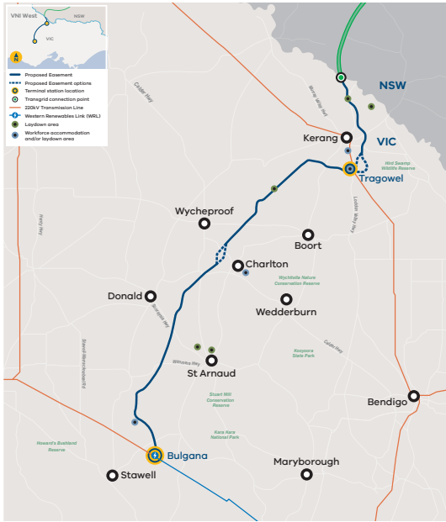
Figure 6: Location of VNI West across Victoria and NSW

Operation
Operation refers to activities the TNSP will complete once the infrastructure is built and in use. These activities will enable the Project to function according to its objectives and be maintained according to legislation, regulatory and public safety standards.
The operation and maintenance of transmission lines are governed by strict regulatory controls to protect public safety and the uninterrupted supply of electricity. All transmission line operators must comply with these requirements and regularly report to relevant authorities, including Energy Safe Victoria.
Key operation activities include:
- Regular inspections and maintenance of the transmission line and terminal station infrastructure, including thermographic and LiDAR inspections (both ground-based and aerial) to identify issues like overheating, faults, and line degradation
- Bushfire/fire risk prevention surveys and inspections, including annual aerial inspections of transmission lines, easements, vegetation, and access tracks
- Vegetation removal/management to maintain electrical safety clearances along the transmission line Proposed Easement, including weed spraying
- Vehicle patrols of access tracks and roads to ensure safe access
- Emergency flyovers and repairs in response to unplanned outages or emergencies

Decommissioning
- Decommissioning refers to the retirement of the Project infrastructure once it has reached the end of its service life. The operational life of the Project is anticipated to be approximately 50 to 100 years. Following operation of the Project, the transmission line and supporting infrastructure such as the terminal station would be decommissioned or repurposed.
- Decommissioning activities would be conducted in accordance with the relevant legislative requirements, industry standards, landholder requirements and best practice relevant at the time and would be managed as part of a Decommissioning Management Plan (refer to EES Chapter 28: Environmental Management Framework).
- As part of decommissioning, it is assumed that all above-ground infrastructure, such as towers, structures, buildings, electrical, ancillary and auxiliary equipment would be removed. All footings would be excavated and demolished to at least 600 mm below ground level and then backfilled with suitable material. The remaining portion of the footings below 600 mm would remain in-situ to minimise the disturbance associated with decommissioning activities. All waste would be managed in accordance with the relevant legislative requirements and industry standards.
- Once the facilities are demolished the areas would be rehabilitated in accordance with the relevant legislative requirements, industry standards, and Project approvals.

Stakeholder engagement
Effective coordination and integration of engagement with Traditional Owners, key stakeholders, Council, landholders, and the community has been central to VNI West Project planning and design.
Engagement on the Project began in early 2023 and, subject to approvals, would continue through secondary approvals, construction, and operation, including ongoing engagement with landholders and neighbouring landholders.
The Project has been refined throughout its life via consultation with Traditional Owners, landholders, community members, key stakeholders, council and government agencies, and supported by additional investigation and technical studies. Feedback and local knowledge gathered through engagement informed the opportunities and constraints mapping and helped establish the criteria to identify the Proposed Easement.
VicGrid VNI West engagement has sought to align with six key engagement objectives:
- Stakeholders understand what VNI West is, how the local area may be impacted, the underlying Project need, and accept the Project
- Relevant stakeholders have participated and provided their feedback throughout the Project lifecycle, and stakeholder views are meaningfully considered and reflected in decision-making
- Stakeholder views regarding preferred methods and opportunities for engagement are known and observed wherever possible
- Engagement and communications processes comply with all regulatory requirements and encourage opportunities for participation
- VicGrid VNI West’s brand is strengthened as a result of the manner in which engagement and communications are delivered
- Project teams develop working relationships with stakeholders which can be maintained and shared
The Project’s engagement program consisted of a combination of face-to-face and online forums, supported by digital, print and in-person methods.
Local councils and relevant government agencies were also engaged through the EES technical reference group (TRG), which provided advice on key issues and concerns from their respective areas of interest (see Section 6).
If the Project receives approval through the EES process, VicGrid VNI West would continue engagement throughout construction, operation and decommissioning of the Project through the implementation of a Community and Stakeholder Engagement Plan. Traditional Owner Engagement and Communications Plans would also be developed and implemented in consultation with the relevant Traditional Owner groups to support participation, communication and continuous improvement.

Engaging with Traditional Owners
VicGrid VNI West acknowledges and respects the deep and enduring connection of Traditional Owners to Country to the lands across on which the VNI West Project is proposed including:
- Barapa Barapa
- Wamba Wemba
- Wotjobaluk, Jaadwa, Jadawadjali, Wergaia, and Jupagalk Nations (represented by the Barengi Gadjin Land Council)
- Dja Dja Wurrung (represented by the Dja Dja Wurrung Clans Aboriginal Corporation)
- Other Traditional Owners who have connection to the Country that the Project crosses
The Project is located across two Registered Aboriginal Party (RAP) areas, including Barengi Gadjin Land Council and Dja Dja Wurrung Clans Aboriginal Corporation, and one non-RAP area.
Through the development of the Project and preparation of the technical studies, VicGrid has engaged with the RAPs, Traditional Owners and First Peoples-State Relations to avoid and minimise potential impacts on Aboriginal cultural heritage values and areas of sensitivity through design, where practicable.
VicGrid VNI West is committed to engaging with Traditional Owners and RAPs in a culturally appropriate way that supports free, prior and informed consent. Engagement has been early, ongoing, and tailored to Traditional Owners’ preferences and capacity.

Community and landholder engagement
Community and landholder engagement has been integrated with Project planning and design to support informed participation, identify local values and constraints, and refine the route and reference design to minimise impacts. Community events and meetings have provided opportunities for people to learn about the Project, ask questions, and provide feedback. Feedback has been collected, recorded, and considered as part of the ongoing development and refinement of the Project.
Formal engagement and communication channels include stakeholder briefings and interviews, community pop-up events, workshops and round-table meetings, interactive digital tools, a Project hotline and email, feedback forms and online surveys, in-person regional engagement hubs, and webinars.
Community consultation has focused on providing timely, accessible information and creating opportunities for two-way dialogue throughout the EES process. Feedback and local knowledge have contributed to identifying environmental, cultural, social, and land-use considerations that have informed route refinement and design development.

Landholder consultation
Direct engagement with stakeholders within the Draft Corridor commenced in August 2023. The feedback received has continued to support understanding of local constraints and land use on individual properties. This information has informed the location of the Proposed Easement and key Project components. The Project team has engaged directly with landholders to discuss micro-siting of infrastructure.
Landholder consultation continues to be supported through a dedicated Landholder Liaison role for landholders impacted by the Project, enabling tailored discussions on property and farm characteristics, access requirements, construction planning, and compensation and other payments associated with the Project.

Planning for VNI West

Required Project approvals
The Project requires assessment and approvals under both Victorian and Commonwealth legislation.
The EES process under the Environment Effects Act 1978 (EE Act). The EE Act provides a means to assess the potential effects of the Project on the environment.
The EES process is not an approvals mechanism, but it provides decision makers with information to assist them to determine whether to grant statutory approvals for the Project, and if so, what conditions should apply.

Victorian
The Project was referred to the Victorian Minister for Planning for advice on the requirement for an EES under the EE Act. The referral was accepted on 6 February 2024. On 13 April 2024, the Minister determined that an EES is required.
Following the Minister’s assessment of the EES, project approval decisions would be made by the relevant Commonwealth and Victorian statutory authorities. The Project would require a number of primary approvals including:
- Approval under the Commonwealth Environment Protection and Biodiversity Conservation Act 1999 (Cth) (EPBC Act)
- Approved Cultural Heritage Management Plans (CHMPs) prepared in accordance with the requirements of the Aboriginal Heritage Act 2006 (Vic) (AH Act) and Aboriginal Heritage Regulations 2018 (AH Regulations)
- Proposed Ministerial Planning Scheme Amendment which would include the introduction of a Specific Controls Overlay and corresponding Incorporated Document for the Project to each of the Gannawarra Planning Scheme, Buloke Planning Scheme, Northern Grampians Planning Scheme and Loddon Planning Scheme for the transmission assets in accordance with the Planning and Environment Act 1987 (Vic) (P&E Act)

Commonwealth
On 13 June 2024, the delegate for the Commonwealth Minister of the Environment, the Department of Climate Change, Energy, the Environment and Water (DCCEEW) made the decision that the Project is a controlled action under the EPBC Act and as such would require assessment and a decision about whether approval should be given under the EPBC Act.
The relevant Matters of National Environmental Significance (MNES) under the EPBC Act cited in the decision are:
- Ramsar wetlands
- Listed threatened species and communities
- Listed migratory species
The Victorian EES assessment process undertaken under the EE Act is being used as an accredited assessment process for the purposes of the assessment of the Project under the EPBC Act, in accordance with the bilateral assessment agreement between the Commonwealth and Victorian governments.
After considering the EES and the Minister’s assessment under the EE Act, the Commonwealth Minister for the Environment or their delegate will decide whether the action is approved, approved with conditions, or refused under the EPBC Act.

6.1.3 Secondary approvals
A range of secondary approvals may be required for the Project under Victorian legislation, which would be sought after the primary approvals have been obtained and prior to construction commencement. These may include, but are not limited to:
- Approval and tenure provisions for commercial and non-commercial purposes on reserved Crown land under the Crown Land (Reserves) Act 1978 (Vic) (Crown Land Act)
- Permits under the Flora and Fauna Guarantee Act 1998 (Vic) (FFG Act) for clearance of FFG Act-listed species within Crown land
- Permit or consent for management of impacts on historic heritage under the Heritage Act 2017 (Vic) (Heritage Act) for works on sites protected under the Heritage Act
- Works on waterways Permit under the Water Act 1989 (Vic) (Water Act)
- Authorisation under the Wildlife Act 1975 (Vic) (Wildlife Act) for the necessary control or management (including removal or salvage activities) of wildlife as defined under that Act
Read more: Chapter 5: Legislative framework

EES process
The EES process provides an assessment of the potential environmental, social, cultural and economic impacts associated with a project. It is designed to be rigorous and transparent, with opportunities provided for stakeholders, including the wider community, to have input.
The Minister for Planning will review the EES, public submissions and the recommendations in the Inquiry and Advisory Committee’s report, and may recommend changes to the proposed management of the Project. The Minister’s assessment of the Project will inform decisions on the statutory approvals nominated in Section 6.1.1.
Relevant decision-makers will carefully consider the Victorian Minister for Planning’s assessment - including the Minister’s conclusions and recommendations regarding the acceptability of impacts - before making decisions on Project approvals.

EES Scoping Requirements
The matters to be investigated and documented in the EES are set out in the EES scoping requirements issued by the Minister for Planning.
Draft scoping requirements for the Project were exhibited by the Department of Transport and Planning (DTP) for public comment between 28 November 2024 to 18 December 2024. After considering public submissions, the Minister published final scoping requirements in February 2025.
The Scoping Requirements for the Project establish the matters to be investigated and assessment priorities for the EES. The Scoping Requirements ensure that the EES properly responds to the reasons why an EES is required, identifies potentially significant environmental effects and requires the proponent to outline how environmental effects of the proposed works would be avoided, mitigated or managed throughout each project phase. The technical studies have responded to these objectives. The EES has been prepared in accordance with the final Scoping Requirements. Environmental themes, investigation priority, and relevant EES chapters are shown in Table 1.
Table 1: Environmental themes, investigation priority and EES chapters
Priority | Environmental Theme | EES Chapters
High priority | Biodiversity and habitat | - Chapter 26: Ecology  - Chapter 27: Matters of National Environmental Significance
High priority | Aboriginal cultural heritage | - Chapter 25: Aboriginal cultural heritage
High priority | Land use and socioeconomic | - Chapter 20: Agriculture  - Chapter 22: Business and economics  - Chapter 23: Land use and planning  - Chapter 24: Social
Medium priority | Historic heritage | - Chapter 11: Historic heritage
Medium priority | Landscape and visual | - Chapter 17: Landscape and visual
Medium priority | Greenhouse gas | - Chapter 15: Greenhouse gas
Medium priority | Climate change | - Chapter 13: Climate change
Medium to low priority | Catchment values and  hydrology | - Chapter 09: Geology and soils  - Chapter 10: Groundwater  - Chapter 14: Surface water
Medium to low priority | Roads and transport, aviation, community amenity and electromagnetic fields | - Chapter 08: Electric and magnetic field  - Chapter 12: Bushfire  - Chapter 16: Air quality  - Chapter 18: Traffic and transport  - Chapter 19: Noise and vibration  - Chapter 21: Aviation

Technical reference group
A technical reference group (TRG) was convened by DTP to advise on the scoping requirements and consultation plan for the EES, along with the scoping, content and adequacy of the technical appendices and EES chapters.
Agencies invited to participate in the TRG include representatives from government, regional authorities, municipal councils and RAPs with statutory, policy or technical interests in the Project. The organisations represented on the TRG are listed in Table 2.
Table 2: TRG organisations
Technical reference group members
Agriculture Victoria
Barengi Gadjin Land Council
Buloke Shire Council
Country Fire Authority
Department of Transport and Planning – Impact Assessment
Department of Energy, Environment and Climate Action (DEECA) – Planning and Environment Assessment
Dja Dja Wurrung Clans Aboriginal Corporation
DTP Planning
Environment Protection Authority Victoria
First Peoples – State Relations
Gannawarra Shire Council
Goulburn-Murray Water
Heritage Victoria
Loddon Shire Council
North Central Catchment Management Authority
Northern Grampians Shire Council

EES assessment framework
To ensure a consistent and transparent approach to the evaluation of potential impacts, an assessment framework was developed and adopted for the Project, provided in EES Chapter 6: Assessment framework.
The framework draws on the EES Scoping Requirements, relevant statutory approval requirements, the Project development and alternatives assessment process, and the findings of the technical studies undertaken for the EES.
The framework recognises that the Project is a major linear infrastructure development with the potential to affect a wide range of environmental, cultural heritage, land use and social values. It also recognises that many potential effects are interconnected and cannot be considered in isolation. Accordingly, the assessment has been undertaken in a coordinated way across technical disciplines so that related impact pathways, shared receptors and management responses are addressed consistently across the EES.
The technical studies were undertaken using an integrated and iterative approach that considered existing conditions, relevant Project activities, potential impact pathways, initial risk screening, sensitive receptors, and the measures proposed to avoid, minimise and manage adverse effects. The technical studies also considered cumulative impacts. These are impacts that occur from the combined effects of the VNI West Project with other proposed projects.
Where adverse effects from the Project have been identified, the studies have considered the extent to which those effects can be avoided, minimised or managed through Project design, or implementation of Environmental Performance Requirements (EPRs). EPRs define the environmental outcomes that the Project must achieve through the construction, operation and decommissioning stages. An Environmental Management Framework has been established, outlining the processes to assure the implementation of the EPRs.
Residual impacts have then been identified as the impacts expected to remain after mitigation defined by EPRs has been implemented.
Figure 7 summarises the EES assessment framework.
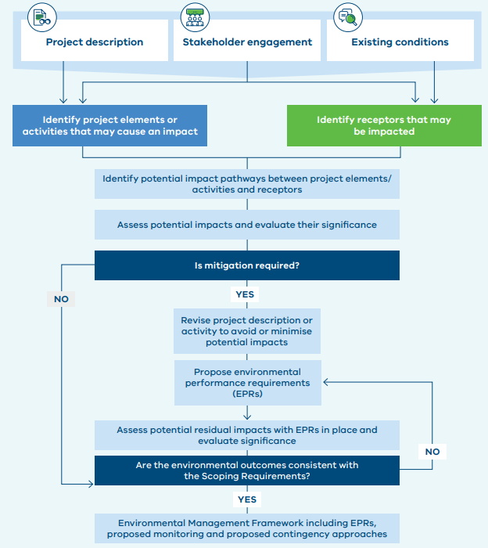
Figure 7: EES assessment framework

Cumulative impacts
Cumulative impacts may occur where multiple activities affect the same receptor or value within the same area and timeframe, such that the combined effect is different from, or greater than, the effect of the Project in isolation. Whether there is sufficient information available to support a meaningful assessment must also be determined.
The approach adopted within the technical study was proportionate to the discipline being assessed, recognising that cumulative impacts are not relevant to all impact pathways and that the spatial and temporal extent over which cumulative impacts may occur differs between disciplines.
In assessing cumulative impacts, it is also recognised that some developments, particularly those that are proposed, referred or identified in strategic plans, may not proceed or may not be developed to their full extent.
The key proposed projects considered in the EES for cumulative impacts include:
- Avonbank Mineral Sands Project
- Cannie Wind Farm
- Donald Mineral Sands Project
- Goschen Mineral Sands Project
- Kerang II (CleanGen2) Solar Farm
- Macorna Wind Farm
- Navarre Green Power Hub
- New Sky Tragowel Solar Farm
- Normanville Energy Park
- Watta Wella Wind Farm
- Western Renewables Link Project
- Wilkur Energy Park
- Wimmera Intermodal Freight Terminal Precinct
- Wimmera Plains Wind Facility
- Wimmera Renewable Energy Solutions
- Virya Energy Meering West Wind Farm
- VNI West – NSW component

Environmental Performance Requirements (EPRs)
EPRs are the core environmental commitments proposed for the Project arising from the EES, to be implemented through the Environmental Management Framework.
The purpose of the EPRs is to reduce the potential environmental effects of the Project as far as reasonably practicable, or to levels where statutory compliance is achieved and the EES Scoping Requirements have been satisfied.
EPRs to mitigate and minimise effects on the environment during Project design, construction, operation and decommissioning were identified in each technical study undertaken for the EES. The recommended EPRs were refined to a set of final EPRs adopted as commitments by VicGrid VNI West and included in the Environmental Management Framework for the Project.
The EPRs adopt a performance-based approach. Rather than prescribing every detailed method, design response or construction technique in advance, they define the environmental outcomes that must be achieved and the matters that must be addressed through subsequent design development, management plans and implementation measures. This approach is appropriate for a project where some aspects of design and construction planning will be refined after completion of the EES – such as the locations of access tracks.
This performance-based approach is important because it allows later design and delivery decisions to respond to site-specific circumstances, landholder input, engineering requirements and construction planning, while remaining within the environmental parameters established through the EES.
Compliance with the EPRs is an obligation of the Incorporated Document and other statutory approvals, and is subject to monitoring, audit and regulatory oversight. Compliance with EPRs would also be independently reviewed and verified by an Independent Environmental Auditor (IEA).
Read more: Chapter 29: Conclusion and Chapter 28: Environmental Management Framework

Ecologically Sustainable Development (ESD) principles and objectives
The Project has due regard to the Ecologically Sustainable Development (ESD) principles by facilitating the transmission of renewable power from REZs in Victoria and NSW and strengthening the reliability and security of the Victoria-NSW electricity network. The Project would contribute to the long-term environmental and social sustainability of Victoria’s energy system. The EES has also considered the principles of ESD through the integrated assessment of the Project’s environmental, social and economic effects, the iterative refinement of the Project to avoid and minimise impacts to the extent practicable, and the proposed EMF and EPRs for the management of residual impacts.
In this respect, the principles of ESD are reflected through the Project development process, the assessment framework, the topic-specific assessments, and the commitments proposed for later stages of the Project.

Project development
The Project has been in development since AEMO’s 2018 ISP confirmed the need for a new interconnector, commencing with the RIT-T to assess the need for new interconnection and supporting network capacity between Victoria and NSW. This process considered a range of concepts, including upgrades to the existing network (South Morang to the Murray River) and new alignments via Bendigo, Shepparton, and Kerang, to support renewable energy developments and future power system requirements in northern Victoria.
The Project has been progressively developed via multiple stages through regulatory assessment, engineering design, environmental assessments and consultation with Traditional Owners, landholders, community members, government agencies and other stakeholders.
This process refined a broad area of investigation in northwest Victoria, to an Area of Interest, to a Draft Corridor (approximately 2 km on average in width), which in turn narrowed down to a Proposed Easement to locate the transmission infrastructure.
Area of Interest (2019 - June 2023)
The Area of Interest was the broad starting area identified for the Project through earlier strategic planning. It provided the wider area within which route options could be investigated before more detailed refinement.
- 5,000+ properties
- Up to 50 km wide
Draft Corridor October 2023
The Draft Corridor is a refined study corridor developed from the broader Area of Interest through more detailed environmental, cultural heritage, agricultural, technical, engineering and planning assessments.
- 500+ properties
- Up to 2 km wide
Preferred Easement October 2024
The current preferred, approximately 70-metre-wide route for the proposed VNI West 500 kV transmission line in Victoria, identified through route refinement, technical studies and consultation as the least constrained location within, and in some locations adjacent to, the Draft Corridor.
- 221 properties
- ~70 m wide
Tower optimisation November 2024 – 2027
Tower optimisation refined proposed tower locations within the Preferred Easement responding to landholder feedback, property layouts, farming operations, technical requirements and environmental considerations.
Key considerations used to avoid and minimise impacts while narrowing the Area of Interest to the Proposed Easement
- Places of Aboriginal cultural significance
- Biodiversity and threatened habitat, including conservation and flora reserves
- Existing and future land use including agriculture and infrastructure requirements
- Proximity to dwellings, schools and hospitals
- Incompatible land uses such as transport networks, airfields and airports
- Geography and topography of the land, including terrain and waterbodies
- Overall length required for the transmission route and number of landholders impacted
- Reducing the number of transmission line angle deviations where possible
- Accessibility for renewable energy developers

Refining the Project to find the Proposed Easement

Area of investigation
The RIT-T process is an economic cost-benefit test to establish the business case for the Project and to confirm that the investment, ultimately funded by consumers, would deliver positive net market benefits to consumers. The RIT-T process does not examine matters related to social and environmental impacts on local communities, unless it conflicts with the law.
The RIT-T process included the production of four reports by AEMO, the second of which was the Project Assessment Draft Report (July 2022) which identified and sought feedback for the defined area of investigation: the area between Bulgana in Victoria and Dinawan in NSW as the region to deliver the Project.
Read more: Chapter 3: Project development and alternatives and Attachment VI: Detailed Project development and alternatives

Options evaluation framework
An evaluation framework was developed for the Project, where key environment, planning, heritage, social, health and safety and land use considerations were identified and used to evaluate proposed options for the Project. The evaluation framework was used to refine the broad area of interest down to a Draft Corridor and subsequent Proposed Easement.
The selection process was based on the principles of:
- Avoiding environmental, cultural and social sensitivities wherever practicable
- Minimising potential impacts
- Maintaining technical integrity
Some features such as major townships, airports, National Parks and Ramsar wetlands were considered to be totally unsuitable for the direct location of transmission infrastructure and required separation distances to ensure that impacts would be minimised. Other considerations such as flood prone land or areas of remnant vegetation were not considered to be ‘fatal flaws’ for the location of transmission infrastructure but were avoided to the extent practicable. Where avoidance was not possible, infrastructure could still be located in these areas with appropriate mitigation measures.

Area of Interest
The fourth and last report of the RIT-T process, AEMO’s Project Assessment Conclusions Report (May 2023), identified the final preferred Area of Interest option (initially identified as option 5A). The Area of Interest (option 5A) demonstrated favourable economic modelling, fewer environmental and cultural constraints and was expected to harness more renewable energy generation.
The Area of Interest was a broad 5–50 km in width, stretching from central northwest Victoria to the Murray River, including locations for connecting the Project into the existing network.

Draft Corridor
The overall approach adopted to refine the Area of Interest down from the approximate 5–50 km width to the Draft Corridor was based on the principle of ‘avoidance’ of sensitive environmental, social and cultural values wherever possible. If engineering, technical and financial criteria were the only criteria used to locate the infrastructure, the Draft Corridor would most likely consist of a straight line over the shortest distance between connection points.
Technical desktop studies and preliminary stakeholder engagement were conducted within the Area of Interest to identify potential environmental constraints from early 2023 – February 2024. Engagement included Traditional Owners, landholders, community members, government agencies, and other stakeholders. The engagement process resulted in many valuable local insights to inform the constraints assessment, which allowed the Area of Interest to be narrowed down to a 2 km wide (on average) Draft Corridor.
The Draft Corridor, as the least constrained corridor, was the Project area referred to the Minister for Planning under the EE Act.

Proposed Easement
Following selection of the Draft Corridor, a Proposed Easement for the Project was identified using the evaluation framework.
This process was informed by community and stakeholder consultation, as well as desktop and field investigations in the Project area, undertaken prior to the EES referral being lodged in February 2024, as well as those conducted as part of the EES.
As desktop and preliminary field investigations progressed during the EES, VicGrid VNI West gained a more detailed understanding of the values within and in proximity to the Draft Corridor. Field investigations were conducted on public and private property; however, due to land access limitations across much of the Project, surveys on private property were generally focused to the north. Some of the key findings from these preliminary field investigations included:
- Unregistered areas of sensitive cultural heritage values
- Locations of sensitive habitats, remnant vegetation, and scattered trees
- Confirmation that several properties with modelled ecological values were in fact heavily modified through agricultural activities and thus unlikely to exhibit the ecological value reflected in desktop data
- Locations of habitable and uninhabitable dwellings
VicGrid VNI West continued consultation with Traditional Owners which included workshops and On Country days, which provided valuable insights into key issues and concerns. In several instances, these consultations yielded information not available from public databases or mapping sources.
As with selection of the preferred corridor, the focus of the easement selection process was to avoid as many sensitive values as possible and identify the least technically and environmentally constrained location for the 500 kV transmission line infrastructure.
The ‘avoidance’ principle was adopted throughout the easement selection process where sensitive values and constraints were avoided entirely, or to the extent practicable, depending on the sensitivity of the value or constraint. Adoption of the avoidance principle, and application of the evaluation framework, resulted in an easement which regularly deviates from the most direct route available as it moves through the landscape. In some highly constrained areas, it was necessary to traverse areas outside the Draft Corridor.
In six highly constrained areas, (Bulgana, Teddywaddy, Glenloth East, Meering West, Tragowel and Murrabit West), it was determined that more extensive studies and community engagement were required before the options being assessed in these areas could be narrowed down to a single easement. The evaluation and comparison of each of these options is explored in detail in EES Attachment VI: Detailed project development and alternatives. In some areas, it was necessary to traverse areas outside the Draft Corridor.
During the development of the EES, it was determined that the Meering West southern easement option was fundamentally flawed due to ecological and cultural heritage sensitivities following extensive community and stakeholder feedback, and the results from desktop and field investigations undertaken as part of the EES. As a result, only two easement options (Teddywaddy and Tragowel) are presented in the EES.
The Proposed Easement resulting from this refinement process and assessed within the EES is 70 m wide, with wider areas (approximately 170 m wide) required at two transposition locations, with two route options remaining at both Teddywaddy and Tragowel.

Tower optimisation
While the Proposed Easement was being developed, the potential location of each individual tower within the Proposed Easement was progressively drafted.
The process of siting each tower included the initial tower siting process, progressive refinement as technical assessments advanced during the EES and a subsequent stage of consultation and assessment that optimised the final location of the Proposed Easement and transmission towers.
Stakeholder engagement and the desktop and field assessments undertaken for the EES identified sensitive ecological and cultural heritage values present within the Proposed Easement, including remnant native vegetation and areas of unregistered cultural heritage. These findings identified opportunities to microsite towers to avoid or minimise impacts on sensitive values, including at river crossings.
Landholders, land liaison representatives, TRG agencies and other stakeholders were provided the opportunity to give feedback on the Proposed Easement and tower locations. The feedback received identified locations where minor tower adjustments could avoid or minimise potential environmental or land use impacts.
All potential new tower locations were assessed from an environmental and technical perspective, then reviewed by a committee of technical and environmental specialists. Where practicable, the changes were incorporated into the Proposed Easement assessed in the EES.

Undergrounding options
The EES Scoping Requirements required that a robust alternatives assessment be undertaken comparing underground and overhead transmission. This assessment is provided in EES Attachment V: Comparative assessment of overhead and underground transmission technologies and summarised in EES Chapter 3: Project development and alternatives.
Undergrounding was found to be technically feasible in principle but not a practical or economically viable alternative to the proposed 500 kV overhead double-circuit transmission line for VNI West, due to substantially higher cost, longer delivery timeframes, greater constructability complexity, and increased operational and environmental constraints at the Project scale.
Three undergrounding options were assessed:
- A full-length 500 kV high voltage alternating current (HVAC) underground cable option, connecting at Tragowel Terminal Station, up to the Murray River border
- A full-length 525 kV high voltage direct current (HVDC) underground cable option up to the Murray River border, including associated converter stations at each terminal point and at the mid-point interface
- Partial undergrounding, which consists of a 500 kV overhead transmission line and underground cabling via horizontal directional drilling (HDD) for the five main river crossings along the Proposed Easement
Overall, undergrounding would require a capital investment approximately seven to ten times higher than overhead transmission and would take at least twice as long to deliver.
Partial undergrounding would still require substantial additional permanent infrastructure (including transmission stations and at each river crossing) and would materially extend the construction program. These costs and schedule impacts are inconsistent with the Project objectives for timely, cost-efficient delivery and the delivery of net market benefits for consumers.
From a technical and operational perspective, full underground HVAC introduces additional design and site considerations, including thermal management along the route and longer fault repair times requiring excavation. HVDC provides advantages for long point-to-point transfer but is less suited to a corridor that requires multiple connection points and integration with the existing AC network, and would require large converter stations that increase footprint, complexity, and cost.
From an environmental land-use perspective, undergrounding can reduce visual impacts and avoid direct disturbance at waterway crossings where HDD is used. However, a full underground cable would require extensive, ground disturbance along the entire length of the cable, increasing the potential for impacts to sensitive ecological values (including grassland and wetlands) and cultural heritage. Partial undergrounding reduced direct impacts within waterways but also introduced localised construction footprints and permanent infrastructure at river crossings. Overhead transmission provides greater flexibility to avoid and minimise impacts through route selection and micro-siting of towers, with disturbances largely confined to the discrete tower footprint.
The undergrounding assessment concluded that overhead transmission is the preferred solution for VNI West. It provides the most appropriate and efficient technical outcome to meet the Project objectives and is assessed as comparatively less impactful on sensitive environmental and heritage values than underground transmission at the Project scale.

How engagement shaped the Project
Traditional Owners, landholders, community members, and other stakeholders have provided valuable feedback and insights that have been critical in shaping the Project.
Key changes to the Project due to engagement are summarised in the following pages.
Area of feedback: Route refinement
How it shaped the project: RIT-T assessment and selection of preferred option
- During the RIT-T process stakeholder feedback led to five new transmission options to be considered that were further west than originally proposed. In addition, social, environmental and cultural values were included in the assessment.
- Feedback and concerns raised in relation to the preferred Option 5 led to further assessments. Ultimately Option 5A was selected as the preferred option, which was a modification of Option 5.
How it shaped the project: Route refinement and selection of Proposed Easement
- Based on community and landholder input on constraints and in addition to desktop studies, the Area of Interest was narrowed to a Project Easement that minimised impacts to communities and to environmentally and culturally sensitive areas. This included consideration of populated areas, intensive farming operations and habitable dwellings, steep or hilly topography, scenic high points, sensitive wetlands, significant flora and fauna, existing and planned infrastructure, areas of high bushfire risk and a range of other factors
How it shaped the project: Consideration and assessment of proposed route options in Tragowel, Meering West and Teddywaddy
- In response to feedback from the community, and interest from landholders open to siting transmission infrastructure on their properties, VicGrid VNI West assessed several new route options in the Tragowel area.
- In Meering West, community and Traditional Owner feedback and ongoing assessments identified sensitive features in the original Draft Corridor – including lakes, wetlands, flora and fauna, and areas of cultural heritage. In response, VicGrid VNI West identified an additional route option between Meering West and Dingwall.
- In the Teddywaddy area, landholders, community members, and Traditional Owners, provided VicGrid VNI West with greater insight into existing environmental, social and cultural conditions that required further investigation. The Project progressed two route options, a southern option and a western option, in the Teddywaddy area through the EES assessment process.
Area of feedback: Tower location and design
How it shaped the project
- Based on the feedback provided by 59 landholders, VicGrid VNI West changed the location of 258 towers. This included shifts to minimise vegetation impacts, avoid access tracks on farms and optimise setbacks from property boundaries.
- Tower locations were also changed to accommodate findings from the CHMP fieldwork to ensure protection of areas of cultural significance.
Area of feedback: Landholder engagement and compensation approach
How it shaped the project
- Feedback provided by CRG members informed the Option for Easement approach, process, and rollout strategy including timing.
- The Land Easement and Access Package incorporated feedback received by landholders and provided the detailed information landholders were asking for including project benefit payments and indicative property-specific impact compensation and field access terms.
- In response to feedback, VicGrid VNI West increased LAA payments to landholders who provided larger areas for survey access.
Area of feedback: Workforce accommodation and laydowns
How it shaped the project
- An expression of interest issued to the public, assisted in identifying several preferred laydown and workforce accommodation sites, of which nine were progressed for further investigation as part of Workforce the EES.
Area of feedback: Community and stakeholder approach
How it shaped the project
- In response to community feedback and requests VicGrid VNI West updated and tailored its communication and engagement approach, including:
  - Offering a mix of in person and online engagement meetings and varied ways to provide feedback including hotline, enquiries inbox, interactive map, surveys, CRG, face-to-face conversations
  - Choosing event locations and times that took into consideration farming seasons, practices and responsibilities as best as possible
  - Introducing a town hall style presentation and Q&A at the October 2023 community events in response to requests to be engaged as a group. This was in addition to an informal drop-in information session to cater to the engagement needs of communities with diverse perspectives and attributes
  - Launching a regular newspaper column in December 2023 published across 9 regional newspapers to provide regular print access to information
  - Opening an office in Kerang in January 2024 to establish a regional presence and provide landholders and community members with a location for face-to-face conversations with VicGrid VNI West representatives and landholder liaisons at their convenience
  - Responding to requests for targeted meetings by hosting landholder roundtables in Glenloth East in March 2024 and Tragowel and Murrabit in October 2024
  - Introducing rotating pop-ups in November 2024 across Charlton, Kerang, Boort, Donald and Stawell in response to community requests for a greater regional presence
- VicGrid VNI West responded to community requests on specific topics such as fire risk and insurance, by developing fact sheets, Q&As, and where possible having technical specialists attend community events and CRG meetings
Area of feedback: Social Value Strategy
How it shaped the project
- The Social Value Strategy was designed in collaboration with the SVRG, made up of eleven people from across the Project region, knowledgeable about the Project, and with specialist skills and considerable local knowledge. The CRG also provided input and feedback to refine the strategy.
- The strategy was also informed by findings from a community survey, which asked people for feedback on project impacts and opportunities, focussing on five key areas of community wellbeing: health, cohesion, prosperity, sustainability, security. Insights from VicGrid VNI West Land and Community Liaison teams, based on what they have been hearing through ongoing discussions with landholders and community, further informed the approach. This input directly shaped the strategic focus areas and underlying social value initiatives identified in the Strategy.
- The Strategy will undergo extensive stakeholder consultation and public exhibition in 2026 to ensure initiatives reflect true community needs and expectations.
Area of feedback: Technical assessments
How it shaped the project
- Feedback and concerns received throughout the Project directly informed the technical assessments undertaken as part of the EES, as well as the mitigation measures outlined in Chapter 28: Environmental Management Framework. Landholders that provided access for the completion of surveys further helped inform these assessments.

Project impacts
Assessment of the potential VNI West Project impacts included 19 specialist technical studies; all prepared in accordance with the EES assessment framework and to address matters identified in the EES Scoping Requirements.
Community amenity
- Electric and magnetic field
  - Chapter 8
  - Technical Appendix A
- Air quality
  - Chapter 16
  - Technical Appendix I
- Landscape and visual
  - Chapter 17
  - Technical Appendix J
- Noise and vibration
  - Chapter 19
  - Technical Appendix L
Biodiversity and environment
- Climate change
  - Chapter 13
  - Technical Appendix F
- Greenhouse gas
  - Chapter 15
  - Technical Appendix H
- Ecology
  - Chapter 26
  - Chapter 27
  - Technical Appendix S
Land use and socioeconomic
- Bushfire
  - Chapter 12
  - Technical Appendix E
- Agriculture
  - Chapter 20
  - Technical Appendix M
- Business and economics
  - Chapter 22
  - Technical Appendix O
- Land use and planning
  - Chapter 23
  - Technical Appendix P
- Social
  - Chapter 24
  - Technical Appendix Q
Heritage
- Historic heritage
  - Chapter 11
  - Technical Appendix D
- Aboriginal cultural heritage
  - Chapter 25
  - Technical Appendix R
Land and water
- Geology and soils
  - Chapter 9
  - Technical Appendix B
- Groundwater
  - Chapter 10
  - Technical Appendix C
- Surface water
  - Chapter 14
  - Technical Appendix G
Transport and aviation
- Traffic and transport
  - Chapter 18
  - Technical Appendix K
- Aviation
  - Chapter 21
  - Technical Appendix N
The EES assesses the Project’s potential environmental effects during construction, operation, and decommissioning. The EES identifies the existing conditions and values that could be affected across a range of technical studies and addresses the matters set out in the EES scoping requirements.
Where the sections below use the term study area, they are referring to each discipline-specific assessment area defined by the relevant technical specialist. Each specialist has determined an appropriate study area, at a local, regional, or state scale, to provide the context needed to understand key issues and assess potential Project impacts for their discipline. The study area adopted for each assessment is described in the relevant technical chapter and supporting technical appendix.
The Project design has sought to avoid adverse impacts as far as reasonably practicable, having regard to competing technical, environmental, social, and economic requirements. Potential impacts have been assessed based on the proposed design, construction methods, and operational activities described in EES Chapter 4: Project description.
Where adverse impacts cannot be avoided, technical specialists have recommended EPRs consistent with the mitigation hierarchy (avoid, minimise, manage, rehabilitate, and offset). Opportunities are also sought to maximise the positive benefits of the Project for the local communities where feasible. Following application of the EPRs, the residual impacts on values were assessed.
The following sections provide a high-level summary of the key findings from the EES, with a focus on the likely residual impacts during the construction, operation and decommissioning phases of the Project.

Construction and operation

Electric and magnetic field
Electric and magnetic fields are generated by energised transmission infrastructure but are only relevant during operation, as the Project would not be energised during construction. The main consideration is potential exposure levels at houses near the Proposed Easement and possible impacts on human health. There are also concerns about possible impacts on agricultural activities, including the operation of GPS units or communications equipment in the vicinity of the Project.
Electric and magnetic field exposure is regulated through both Commonwealth and State legislation. The potential electric and magnetic field exposure of the Project has been assessed to check that electric and magnetic field levels are compliant with the relevant reference levels and would not result in impacts to human health and the environment.
This assessment identified and assessed the potential risks to human health due to electric and magnetic field emissions and the potential interference with communication or infrastructure systems
Electric and magnetic field levels dissipate over short distances from transmission infrastructure. When developing the Proposed Easement, a 5 km buffer from townships, and a 300 m buffer from individual dwellings has generally been applied to locate the transmission infrastructure. This ensures electric and magnetic field levels are well within compliance requirements at these dwellings. International studies have concluded that electric and magnetic fields generated by transmission infrastructure do not have adverse effects on livestock.
Predicted electric and magnetic field levels from the transmission line, the Tragowel Terminal Station and the Bulgana Reactor Station are all below relevant public and occupational exposure reference levels. As such, the Project complies with applicable guidelines, and no additional mitigation is required to achieve compliance.
Electromagnetic interference is not expected, including to GPS systems due to different operating frequency ranges. Potential low frequency induction effects and impacts to metallic infrastructure such as fences and services would be confirmed during detailed design in accordance with Australian Standard 2344:2016, supported by testing prior to and following energisation.
Overall, with standard design verification and controls in place, residual electric and magnetic field impacts are expected to be negligible.
All EES documents, chapters, technical appendices and attachments are available to view and download on the VNI West website at vniwproject.com.au/EES
EES Chapter 8 and Technical Appendix A outline the potential impacts to human and animal health, and electronic equipment and signals associated with electric and magnetic fields generated by the Project.

Air quality
The Project is located within a rural area characterised by low population density and limited existing sources of air pollution. Background air quality is expected to be generally good, with the primary contributors to local dust levels being natural and agricultural activities. These include wind-driven dust from exposed surfaces, disturbance of soils associated with farming operations, and wheel-generated dust from vehicles travelling along unsealed roads. Occasional bushfire events may also contribute to short-term reductions in air quality within the study area.
The air quality assessment identifies sensitive receptors as locations where occupants or ecological values may be adversely affected by changes in air quality. This includes dwellings within 250 m of the construction footprint and ecological receptors within 50 m. When accounting for workforce accommodation, laydown areas and access roads that may be utilised during construction, an additional 86 sensitive receptors were identified.
During the construction phase, the primary air quality impacts would be associated with the generation of dust and emissions from construction plant and vehicles. Key dust sources would include demolition activities, earthworks, site clearing, infrastructure construction (such as foundations, drainage systems, buildings and electrical equipment), and the import and export of materials. Dust emissions from construction activities are well understood and can be effectively managed through industry standard controls.
Dust emissions along the transmission line are expected to be negligible due to the low magnitude of earthworks and limited nearby sensitive receptors such as houses. Impacts at the Tragowel Terminal Station, workforce accommodation and laydown areas are also expected to be negligible due to separation distances from houses and other sensitive land uses. The main source of potential dust generation is unsealed access roads which trucks and other vehicles would be utilising to access construction sites within the Proposed Easement.
Mitigation will be implemented in accordance with the EPRs and include minimising disturbed areas, stabilising exposed surfaces, revegetating completed areas, covering loads, applying dust suppression, and stabilising access tracks. An Air Quality Management Plan will be developed and implemented as a sub-plan to the CEMP to minimise air quality impacts during construction. Monitoring and adaptive management will be used to ensure controls remain effective. With mitigation in place, impacts at sensitive receptors are expected to remain negligible.
Emissions from construction plant and equipment are expected to be intermittent and transient, and therefore unlikely to significantly affect local air quality. With mitigation measures in place, residual impacts from exhaust emissions are anticipated to be negligible.
During operation, air quality impacts would be limited to those associated with periodic inspection and maintenance activities for the transmission line and the Tragowel Terminal Station. These activities would involve a small number of light vehicles, resulting in minimal dust and combustion emissions. Given the low frequency and limited scale of these activities, residual operational impacts on air quality are expected to be negligible.
Overall, with EPRs in place, residual impacts on air quality are expected to be negligible across all Project phases.
All EES documents, chapters, technical appendices and attachments are available to view and download on the VNI West website at vniwproject.com.au/EES
EES Chapter 16 and Technical Appendix I outline potential impacts from dust, emissions, and airborne hazards from the Project, and consider measures to minimise dust and emissions from equipment and handling of materials.

Landscape and visual
Victorian legislation recognises the value of landscapes for their intrinsic qualities, for the quality of life and enjoyment of people, and for the economic benefits they bring. Understanding the visual character of these landscapes and their recognised scenic and landscape values helps to assess the severity of impacts resulting from the Project across parts of the region, particularly for receptors (e.g. residences) located near roads, private dwellings, and recreational areas.
The Project comprises seven landscape character areas (LCAs), described as areas of similar patterns or elements in the landscape such as landform, vegetation, waterbodies and land use. Each of these LCAs has a distinct, recognisable and consistent pattern of elements that occur in the landscape.
- LCA 1: Farmland – moderate to high landscape value
- LCA 2: Woody farmland – moderate landscape value
- LCA 3: Native bushland – high landscape value
- LCA 4: Recreational parkland – moderate landscape value
- LCA 5: Lakes, wetlands and swamps – high landscape value
- LCA 6: Riparian corridors – high landscape value
- LCA 7: Township – high landscape value
The Project has sought to avoid topographic high points, townships, parks, reserves, and other recreational or publicly used areas where practicable.
During construction, visual impacts would be temporary and primarily associated with laydown areas and worker accommodation sites. Moderate impacts are anticipated for public receptors travelling along roads adjacent to these areas. Screening vegetation is proposed around construction sites to reduce visibility, and with these measures in place, residual construction impacts are expected to be low.
Construction impacts at lookouts and areas located more than 5 km from the Proposed Easement are expected to be negligible, with minimal change to recreational views.
During operation, transmission infrastructure (towers and lines) would be visible from some roads and nearby private dwellings, with impacts varying depending on proximity and landscape context. Moderate to high impacts are anticipated where infrastructure is located close to or crosses major roads, including highways and arterial routes, and in locations subject to environmental significance overlays. These views are generally exposed and representative of wider landscape conditions, and mitigation is not proposed at most public road viewpoints; therefore, residual operational impacts in these areas would remain moderate to high.
Private dwellings located within 500 m of the Proposed Easement would experience moderate to high visual impacts during operation. Screening vegetation may be implemented subject to agreement with landholders, which would reduce residual impacts to low to moderate in many cases.
Designated lookouts within 5 km of the Proposed Easement would experience moderate operational impacts, while impacts at lookouts beyond 5 km would be negligible due to distance and exposure. Mitigation is not proposed at these locations, and residual impacts would remain unchanged.
Community gathering places would experience moderate operational impacts; however, with screening vegetation where appropriate, residual impacts would be reduced to low.
Overall, while the Project would introduce new and permanent infrastructure elements into the landscape, impacts would vary depending on proximity and viewing context. With implementation of EPRs including screening vegetation and sensitive siting, residual visual impacts are generally expected to range from low to moderate across most locations, with higher impacts limited to areas immediately adjacent to the Proposed Easement.
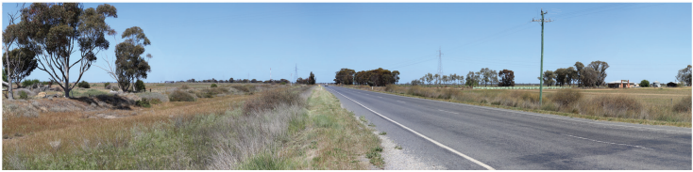
Figure 8: Example of view location in visual impact assessment – View location 19: Existing view
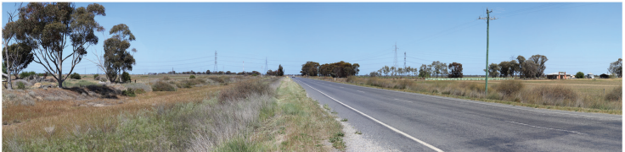
Figure 9: Example of view location in visual impact assessment – View location 19: Photomontage view, showing residual impact of ‘moderate’ for public receptors, and ‘high’ for private receptors
All EES documents, chapters, technical appendices and attachments are available to view and download on the VNI West website at vniwproject.com.au/EES
EES Chapter 17 and Technical Appendix J outline potential impacts from the Project to the character, scenic quality and visual amenity of the landscape, including the way it is perceived and experienced by surrounding communities and visitors.

Noise and vibration
The Project area is generally characterised by low background noise levels typical of rural land uses. The Project has the potential to affect amenity during construction and operation, primarily through temporary construction activities, use of plant equipment, and operational electrical and wind-related noise emissions.
The assessment identified sensitive receptors (e.g. houses) within the noise study area, including houses near the Tragowel Terminal Station, Bulgana Reactor Station, and the nine laydown and/or workforce accommodation areas. Existing noise conditions were measured through attended and unattended monitoring, which found background levels to be typically low and representative of rural environments, dominated by natural and agricultural sources, with localised traffic influence in some locations. This data was used to derive Project specific noise criteria, with conservative background levels applied, particularly for work outside of normal working hours.
Construction is expected to occur predominantly during normal working hours. Construction noise may temporarily interfere with domestic and recreational activities and, in some locations, with tranquility in nearby outdoor areas. However, predicted noise levels at sensitive receptors are generally expected to be similar to, or lower than, existing ambient levels, and construction noise effects are expected to be temporary and localised. Any works outside normal working hours would be limited to low-noise activities, subject to relevant authority approval and compliance with derived criteria.
Construction would involve noise generating activities over the course of approximately 36 months. Activities include, but would not be limited to:
- Foundation construction and piling
- Tower construction assembly and erection
- Conductor stringing (by helicopter, drone or via tensioners)
- Civil works – earthworks and pad construction, and equipment installation
The potential impacts of construction traffic noise on houses located on local roads along the Proposed Easement was also assessed, indicating very few houses on local roads would be subjected to traffic noise above ambient levels and that the noise would be intermittent and of short duration.
The predicted noise levels at the nearest sensitive receptors range from 44 - 51 LAeq,15min dB for Tragowel Terminal Station and 37 - 42 LAeq,15min dB for Bulgana Reactor Station. In comparison with the Environment Reference Standard (ERS) noise objective of 40 LAeq dB, construction noise may interfere with domestic and recreational activities, as well as normal conversation at noise sensitive receptors in the vicinity of Tragowel Terminal Station. Although the predicted construction noise levels exceed the ERS objectives, the predicted levels are similar to or less than the existing ambient noise levels (on average LAeq,7 am – 6 pm 49 dB) which may indicate a reduced risk of impact to environmental values.
For the transmission line, construction noise may interfere with domestic and recreational activities, as well as normal conversation at noise sensitive receptors in the vicinity of the transmission line. Predicted construction noise levels are of the order of 74 LAeq,15min dB(A) for the majority of tower construction works and up to 84 LAeq,15min dB(A) for those activities that require helicopters, noting there is currently no quantitative noise objective to assess human tranquility and enjoyment outdoors in natural areas.
Operational noise sources would include hum or buzzing from electrical equipment and hissing or crackling associated with aeolian and corona effects under certain conditions. Predicted operational noise emissions are expected to comply with relevant criteria at nearby sensitive receptors and can be managed through appropriate separation distances and, where required, additional controls such as noise barriers and design installation measures to minimise corona and wind-generated noise.
Noise and vibration impacts will be managed through the implementation of the Noise Management Plan prepared in consultation with EPA Victoria, supported by monitoring and response procedures as required. Ground vibration from construction has the potential to affect human comfort or structures at very close distances; however, with guideline setback and standard controls, residual vibration impacts are not expected.
With the proposed measures in place, residual impacts on amenity from noise and vibration are expected to be low during construction and low to negligible during operation.
Units of measurement
Ambient noise level (LAeq) is the continuous sound pressure level for all sound occurring during a given measurement period.
Background noise level (LA90) is the average minimum background sound level (in the absence of the source under consideration).
All EES documents, chapters, technical appendices and attachments are available to view and download on the VNI West website at vniwproject.com.au/EES
EES Chapter 19 and Technical Appendix L examine potential noise and vibration impacts from the Project during construction, operation and decommissioning.

Climate change and greenhouse gas
The Project spans two climate zones: a northern zone with hot, dry summers and cool winters, and a southern zone with a mild temperate climate. Both zones were assessed under two future climate change scenarios, and the potential risks to the Project due to climate change were identified using the higher emissions scenario.
The climate change assessment identified key hazards (e.g. flood, drought, extreme wind events) which are projected to intensify over the Project’s operating life and may affect workforce safety, asset performance, access for maintenance and emergency responses, and system reliability.
The location and design of the Project infrastructure have been selected to avoid higher risk areas where practicable. During construction, climate hazards may affect workforce safety, scheduling, and site access. These impacts will be managed through established controls, including weather-related work restrictions, erosion and sediment controls, and emergency preparedness and response arrangements.
During operation, the primary climate risk relates to asset resilience under extreme heat, wind, and rainfall events, and maintaining safe access for inspection, maintenance, and emergency response. Key measures include incorporating appropriate climate allowances in detailed flood modelling for critical sites, designing to applicable wind loading criteria, confirming equipment operating requirements under higher ambient temperatures, and implementing ongoing inspection, maintenance, and vegetation management.
Climate-related impacts will be managed through inherent design controls and detailed design measures. The operator will maintain a climate change register for the life of the Project, supported by five-yearly reviews, ongoing monitoring of climate-related impacts, and updates to specific EPRs as required. With these mitigations climate-related impacts are expected to remain acceptable and are not anticipated to compromise the Project’s ability to meet its performance requirements over its planned operating life.
Greenhouse gas (GHG) emissions include carbon dioxide (CO2 ), sulphur hexafluoride (SF6), and methane (CH4), and are reported as carbon dioxide equivalent (CO2 -e). The Climate Change Act 2017 (Vic) provides the legislative framework for managing climate change risks and supports Victoria’s transition to net zero emissions by 2045. Scope 1 and Scope 2 emissions are required to be reported under both the National Greenhouse and Energy Reporting scheme and the GHG Protocol.
The Project would generate GHG emissions during construction and operation through direct sources (e.g. fuel used by vehicles, plant, and equipment) and indirect sources (e.g. embodied emissions in construction materials and associated transport), as shown in Figure 10.
Total Scope 1, Scope 2, and relevant Scope 3 emissions were calculated for each phase of the Project. Overall, total Project lifecycle emissions are estimated at 970,058 t CO2 -e (Scope 1, 2, and 3). The dominant sources of emissions are embodied emissions associated with construction material and asset replacement over the Project life.
Throughout the Project lifecycle measures to avoid and minimise GHG emissions will include selecting low-embodied-energy and locally sourced materials where feasible, designing for durability and low-maintenance to reduce replacement requirements, prioritising fuel-efficient plant and equipment, and diverting waste from landfill. During operation, GHG considerations will be incorporated into asset management planning, supported by safety and emergency controls to minimise fugitive emissions associated with unplanned events.
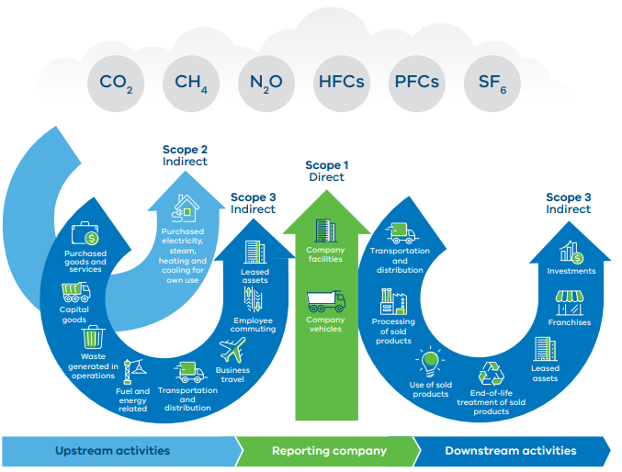
Figure 10: Direct and indirect emissions as defined by the GHG Protocol (Source: GHG Protocol, 2003)
All EES documents, chapters, technical appendices and attachments are available to view and download on the VNI West website at vniwproject.com.au/EES
EES Chapter 13 and Technical Appendix F identify key climate hazards that may affect the Project over its lifecycle, and outlines how impacts would be avoided, minimised or managed.
EES Chapter 15 and Technical Appendix H assess the full Project lifecycle emissions, estimating emissions within the proponent’s control or influence (including materials, transport, and waste).

Ecology
The Project is located in an area that has been largely cleared of native vegetation due to historical and ongoing agricultural land use. Open grazed pasture or cropping lands dominate the Project area with most remnant vegetation restricted to public roadsides and streamside areas with the occasional patch retained within farmland or as scattered trees. A range of ecological vegetation classes (EVCs) occur along the Proposed Easement, predominantly woodland and forest, with localised areas of mallee, grassland, and chenopod shrublands.
Due to the extent of historic vegetation clearance, it was considered a priority during the Project development phase to avoid and minimise impacts on ecological features as much as practicable. Sensitive areas prioritised for avoidance were identified through desktop and field assessments, as well as consultation with Traditional Owners, landholders, communities, and other stakeholders.
As described in Section 7.1.2, EES Chapter 6: Assessment framework, and EES Chapter 26: Ecology, the options evaluation framework was based on the principles of the mitigation hierarchy for the Project, where ‘avoidance’ is the primary mechanism for protecting values (see Figure 11).
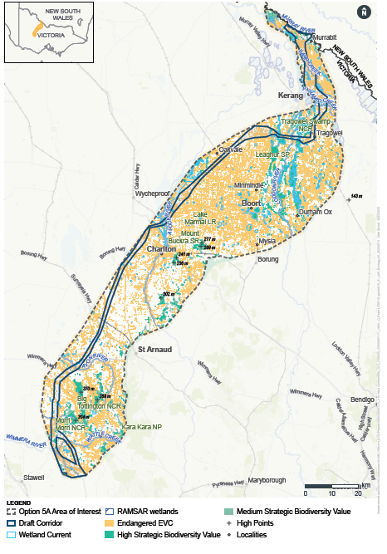
Figure 11: Route refinement process from Area of Interest to Draft Corridor showing strategic biodiversity values
Key ecological areas avoided during this process included:
- Patho Plains Important Bird Area/Key Biodiversity Area
- Core re-introduction area for the critically endangered Plains Wanderer Pedionomus torquatus
- Kerang Wetlands Ramsar Site
- Northern Victorian Wetlands Key Biodiversity Area
- Kara Kara National Park
- Great Spectacle Lakes Complex
- St Arnaud Box-Ironbark Region Key Biodiversity Area/Important Bird Area
- Large wetland complexes
- Leaghur State Park
- Plumpton Wildlife Reserve, Benjeroop Wildlife Reserve, Quambatook Bushland Reserve, Wooroonook Lakes Wildlife Reserve, and Morrl Morrl and Mount Bolangum Nature Conservation Reserves
- Remnant vegetation within streamside corridors
The primary ecology impacts during construction relate to vegetation clearance and ground disturbance associated with towers and associated construction areas, temporary access tracks and stringing sites, as well as ancillary works (including laydown/workforce areas, terminal/reactor station works and localised vegetation clearance at access points and road intersections). Direct impacts include removal of native vegetation and habitat (patches and scattered trees, including hollow-bearing trees), TEC habitat, and habitats for threatened species. Indirect impacts may include impacts on migratory species, disruption to habitat connectivity, degradation of riparian vegetation, exacerbation of threatening processes (including pest animals and fire risk), and impacts on groundwater-dependent ecosystems (GDEs).
In addition to impacts within the defined construction footprint, there is potential for inadvertent impacts outside the footprint if activities extend beyond approved limits; this would be managed through clearly defined limits of disturbance (including No-Go-Zones where required) and environmental controls.
The Project would operate for approximately 50-100 years. Key ecology risks during operation relate to the ongoing presence of transmission towers and lines (including bird collision and electrocution risk), bushfire ignition risk, potential ongoing impacts on GDEs, and ongoing vegetation management beneath transmission lines (including low-level disturbance and the potential spread of weeds and pathogens).
Offsets for native vegetation would be required under Victoria’s native vegetation removal regulations. Offset requirements have been determined using DEECA’s native vegetation removal map to generate a native vegetation removal report. The need for offsets for TECs and listed species habitat under the EPBC Act Environmental Offsets Policy would be confirmed once targeted surveys are completed and impacts are more fully defined.
Overall, while the Project would result in some unavoidable ecological impacts, the application of a rigorous avoidance and minimisation framework, together with targeted mitigation and offsetting measures, is expected to reduce these impacts to an acceptable level within the context of the modified landscape.
Native vegetation and threatened communities
During construction, it is estimated that the Project would result in unavoidable loss of approximately 116 ha of native vegetation patches, 475 large trees in patches, 130 large, scattered trees and 19 small, scattered trees. These impacts would be dispersed along the length of the approximately 240 km Proposed Easement. However, it is likely that the biodiversity and habitat impacts are overstated at this stage of the Project as lack of land access to private properties to conduct surveys has resulted in the EES adopting a conservative approach and assumes that ‘worst case’ losses would occur.
FFG Act listed threatened ecological communities confirmed to occur in the Proposed Easement and would therefore be impacted are Grey Box – Buloke Grassy Woodland, Northern Plains Grassland and Semi-arid Northwest Plains Buloke Grassy Woodland.
Ongoing vegetation management during operation would be required to maintain clearance heights and may result in low-level disturbance beneath the line, with an associated risk of weed and pathogen spread. These risks would be managed through biosecurity controls and the Vegetation and Habitat Management Plan. Although taller vegetation (mature height >9.1 m) within the Proposed Easement would be removed during construction, regrowth and germination may occur over time and would require periodic management. Vegetation maintenance would be undertaken in accordance with DEECA’s utility installations exemption procedure (DEECA 2019), including a written agreement where required; native vegetation would be avoided where practicable, and any further tree removal would require separate approval and offsets. Overall, residual impacts are expected to be low.
Threatened flora and fauna
A total of 5 EPBC Act-listed threatened flora species and 19 EPBC Act-listed threatened fauna species were assessed as having a medium to high likelihood of occurrence within the Project Easement. Surveys have recorded the following EPBC Act-listed threatened species: Turnip Copperburr (flora), Brown Treecreeper, and Striped Legless Lizard (fauna).
FFG Act-listed flora and fauna species recorded to date include Buloke (flora), Umbrella Wattle (flora), Spiny Lignum (flora), Grey-crowned Babbler (fauna), Brown Toadlet (fauna), Samphire Skink (fauna) and Hooded Scaly-foot (fauna).
Overall, the ongoing application of the avoidance principle throughout detailed design and the implementation of proposed management measures during construction are expected to minimise residual impacts on threatened species to an acceptable level. Nevertheless, additional targeted surveys are required to determine the full extent of potential impacts.
Collision risk
Collision risk is highest for larger, less agile species that fly in large flocks and/or at speed, particularly where the Proposed Easement traverses wetland landscapes and key bird movement corridors. These include shorebirds (e.g. Latham’s Snipe), waterbirds (e.g. Brolga), raptors (e.g. the White-bellied Sea Eagle), and ground-dwelling birds (Plains Wanderer). Collision risk in other flying species such as bats is not considered a likely impact due to the nature of the lines. Mitigation would focus on priority locations identified during detailed design, including measures to improve line visibility (e.g. line marking/ bird flight diverters), supported by the monitoring and adaptive management during early operations. These measures would be documented in a Collision Risk Management Plan, developed in consultation with DEECA.
Electrocution risk is highest for species that perch, roost, or nest on infrastructure, particularly large-bodied birds with broad wingspans. Overall, the electrocution risk for high-voltage transmission infrastructure is expected to be low due to structure height and clearances and would be further minimised through final design measures where required (including insulation and/or design refinement). While Carpet Pythons could potentially climb towers, electrocution is unlikely given that conductors are positioned many metres above the ground, and there are no adjacent trees to facilitate access.
Environmental Performance Requirements
EPRs have been developed to guide the ongoing investigations and the incorporation of results into design refinement. Mitigation measures would include, where required: No-Go Zones, weed monitoring and management, retaining and/or replanting understorey, timing of construction activities to avoid breeding seasons, and collision risk management. These measures would be implemented through topic-specific plans (including vegetation and habitat, biosecurity, wildlife, threatened species management, and collision risk management) prepared in conjunction with overarching Project construction, operation, and decommissioning environmental management plans (CEMP, OEMP, and DEMP).
All EES documents, chapters, technical appendices and attachments are available to view and download on the VNI West website at vniwproject.com.au/EES
EES Chapter 26 and Technical Appendix S provide the flora, fauna, and habitat values within and surrounding the Project, and the significance of potential ecological impacts to native vegetation and threatened species. Measures to avoid, minimise and manage have also been outlined.
EES Chapter 27 and Technical Appendix S also provides the biodiversity values and potential impacts of the Project, focussing on EPBC Act-listed Matters of National Environmental Significance.

Bushfire
Bushfires are an inherent hazard across many Victorian landscapes, and the Project area is bushfire-prone. The Project has the potential to influence bushfire risk during construction and operation, primarily through ignition sources, access arrangements, and interactions with suppression activities.
With the implementation of proposed design, construction, and operational controls, bushfire risk in the surrounding landscape is expected to remain high due to existing conditions but is not anticipated to be materially increased by the Project.
The existing environment of the Project is characterised by warm summer conditions, with mean maximum temperatures between November and March generally exceeding 25°C. Bushfire risk is typically elevated following dry winters and springs, when fine fuels become more readily ignitable. Across most of the Proposed Easement, land use is predominantly agricultural grassland, which generally presents lower fire intensity potential than forested environments. The Proposed Easement has been designed to avoid forested areas, including State and National Parks, and areas mapped under the Bushfire Management Overlay (BMO), with interaction limited to approximately 2 km across the 240 km Proposed Easement. Steep topography has also been avoided where practicable to reduce fire spread potential.
Bushfire behaviour in the region surrounding the Project is influenced by the wind. A bushfire in the region surrounding the Project is likely to spread in accordance with two scenarios, namely, when a bushfire is influenced by a north westerly wind and when a bushfire is influenced by a south westerly wind (which occurs after the north westerly wind).
During construction, the presence of plant, equipment, vehicles, and hot works introduces potential ignition sources in an already fire-prone environment. This impact will be managed through a Construction Bushfire Mitigation and Management Plan (CBMMP) and a Construction Fire Emergency Management Plan, developed in consultation with the Country Fire Authority (CFA). Measures include controls for hot works, restrictions during high fire danger periods, workforce accommodation standards, on-site initial response capability, provision of firefighting water, and emergency access arrangements. Temporary worker accommodation would also be designed to provide appropriate protection.
Ignition risk during operation is expected to be lower than during construction. 500 kV transmission infrastructure has not been known to cause a bushfire and is not considered a significant ignition source. Lightning protection, routine inspection and maintenance, vegetation management, and access track maintenance will be implemented through an Operations Bushfire Mitigation and Management Plan and an Operational Fire Emergency Management Plan, also in consultation with the CFA. Early detection measures, such as smoke-detection cameras on selected towers, may be considered during detailed design to support timely response.
Bushfire suppression relies on both ground and aerial firefighting resources. While transmission infrastructure may present some constraints in certain circumstances, suppression operations are managed through established procedures, and with appropriate controls and coordination with emergency services, both aerial and ground-based response is expected to operate safely in the vicinity of the Project. Any temporary disruption during construction will be managed through the CBMMP and Emergency Management Plan.
While the overall risk of bushfire remains elevated due to the surrounding environment, these measures would reduce the likelihood of the Project causing a fire and limit potential impacts. The highest risks are from ignition sources present during construction, with risks being considerably lower once the Project is operational, due to 500 kV transmission lines not being considered a significant ignition source. The proposed EPRs are expected to reduce ignition likelihood and potential consequences through prevention, early detection, and improved emergency response. The Project is not expected to significantly affect bushfire behaviour or response capability, and bushfire risk can be effectively managed through the proposed framework.
All EES documents, chapters, technical appendices and attachments are available to view and download on the VNI West website at vniwproject.com.au/EES
EES Chapter 12 and Technical Appendix E identify potential bushfire risks associated with the Project, including ignition risk, access, and suppression activities.

Agriculture
Agriculture is the dominant land use across the Project, and farming in the Project region (Gannawarra, Loddon, Buloke, and Northern Grampians LGAs) contributes more than 10% of Victoria’s total value of cropping, grazing, and dairy production.
Figure 12 shows the geographic distribution of agricultural activity along the Proposed Easement.
The Project has the potential to influence agricultural production and farm operation, primarily through temporary land occupation and disruption, isolation of productive land (including irrigated areas), operational inefficiency around towers from movement of personnel and equipment.
The Project has sought to avoid areas of known agricultural infrastructure, including irrigation systems and areas of high-intensity agricultural activity such as horticulture and piggeries. Project design has incorporated advice from agricultural technical specialists to minimise impacts through the siting and design of transmission towers.
Construction of the Project would result in temporary disruption to agricultural activities on properties along the Proposed Easement over the approximately 3.5-year construction period. These disruptions would be intermittent and generally short in duration at the individual property level (typically days to weeks), although a broader area of approximately 3,551 ha may be affected at different times during construction. Most land would return to productive use once construction is complete.
The direct economic impact associated with the temporary loss of productive agricultural land during construction is estimated at approximately $2.77 million, representing around 0.3% of the total annual agricultural production value across the four LGAs intersected by the Project. While this represents a minor impact at a regional scale, individual landholders may experience more noticeable effects, including disruption to farm operations, soil disturbance and potential biosecurity impacts.
The direct economic impact associated with the temporary loss of productive agricultural land during construction is estimated at approximately $2.77 million, representing around 0.3% of the total annual agricultural production value across the four LGAs intersected by the Project. While this represents a minor impact at a regional scale, individual landholders may experience more noticeable effects, including disruption to farm operations, soil disturbance and potential biosecurity impacts.
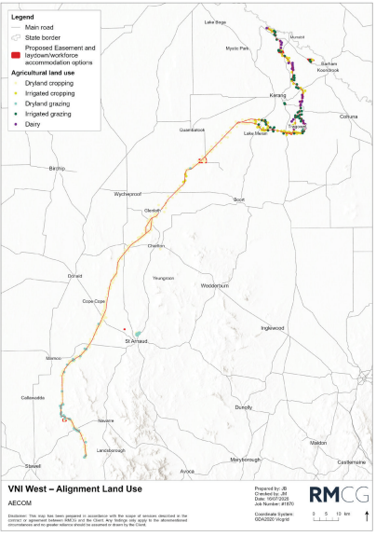
Figure 12: Geographic distribution of agricultural activity in the Project area
All EES documents, chapters, technical appendices and attachments are available to view and download on the VNI West website at vniwproject.com.au/EES
EES Chapter 20 and Technical Appendix M outline the Project’s potential to influence agricultural production and farm operations and consider how disruptions to farmers can be minimised.

Business and economics
The farming industry is the largest sector by number of businesses in the study area, followed by the construction industry. Given its significance, agricultural impacts were addressed in a separate dedicated assessment and excluded here (see Section 8.1.8 and EES Chapter 20: Agriculture).
- Output $25.40 million
- Employment 107 jobs
- Wages and salaries $8.24 million
- Value added $10.68 million
Most non-agricultural businesses are located within regional townships situated well away from the Proposed Easement, meaning direct impacts from construction and operation are limited. The main non-agricultural businesses in proximity to the Proposed Easement are planned or approved renewable energy projects, including wind and solar developments, which would rely on the Project for connection to the electricity grid.
Key issues raised through engagement with businesses and councils include uncertainty around construction timing and approvals, potential impacts on accommodation availability, tourism-related concerns, and labour force availability.
Uncertainty regarding construction timing may influence investment decisions for renewable energy proponents and businesses participating in supply chains. This impact would be managed through ongoing communication and stakeholder engagement to improve certainty around Project staging, procurement opportunities, and delivery timelines.
Potential impacts on housing availability as a result of a temporary influx of construction workers was identified as a concern. However, the Project would utilise temporary worker accommodation facilities, thereby avoiding reliance on local housing and reducing pressure on regional accommodation services.
Tourism impacts were assessed as low due to the location of the Proposed Easement, which avoids major tourism destinations, including parks, reserves, and high-value scenic areas, and is situated well away from the Grampians National Park. As such, impacts to tourism dependent businesses are expected to be minimal.
Labour market impacts are also expected to be minor. While some competition for skilled labour may occur, the use of a predominantly non-local construction workforce would limit pressure on the regional labour supply.
The Project is also expected to generate economic opportunities, including increased demand for local goods and services during construction, increased regional employment opportunities, and improved network capacity to support renewable energy development. Improved access to the electricity grid is expected to reduce curtailment impacts for energy generation projects which would allow them to dispatch more energy to the market.
The key economic outcomes from the Project are shown above.
Implementation of a communications and engagement framework, a local procurement strategy, a local employment plan, and the use of temporary worker accommodation facilities to avoid pressure on local housing and services would help minimise and manage impacts.
Overall, residual impacts to business and economic conditions are expected to be negligible to minor, with a number of positive economic effects associated with employment, procurement, and renewable energy development support.

Land use and planning
The Project would expand Victoria’s electricity transmission network and support renewable energy connections, aligning with state and local planning policy that recognises its role in facilitating renewable energy development and improving system reliability.
The Project would be located across four LGAs (Gannawarra Shire, Loddon Shire, Buloke Shire, and Northern Grampians Shire) over the 240 km Proposed Easement. The Proposed Easement would generally be 70 m wide, except at two locations where it would widen to 170 m. Land use within the study area is predominantly agricultural, with more intensive farming occurring in the northern sections.
The transmission line would traverse a mix of high and low intensity farmland, with limited areas of conservation land associated with water crossings, roads, and waterways including the Murray River, Loddon, Avoca, Avon, Richardson and Wimmera Rivers, Morrl Morrl Creek, and associated reserves. Several arterial roads connect regional townships including Stawell, Navarre, St Arnaud, Donald, Charlton, Boort, Wycheproof, Wedderburn, Kerang, Cohuna and Swan Hill. There are no declared freeways within the study area.
Construction impacts would be temporary and generally confined to the Proposed Easement, Tragowel Terminal Station, and associated laydown and accommodation areas. These impacts are primarily related to amenity, including dust, noise, and traffic. Localised vegetation removal would occur at river and road crossings; however, existing land uses would otherwise remain largely unaffected. Impacts would be minimised and managed via the Project’s Construction Environmental Management Plan, Construction Bushfire Management Plan, Air Quality Management Plan and a Noise and Vibration Management Plan. Residual construction impacts are considered moderate but temporary due to short-term displacement of existing uses.
During operation, impacts would be permanent for the life of the Project but minor in nature. These include the removal of vegetation beneath transmission lines to maintain safety clearances and small ground disturbance areas at the base of transmission towers (typically 20 x 20 m). Agricultural use would largely continue within the Proposed Easement, although some restrictions would apply, including limitations on the use of manned aerial services. The Tragowel Terminal Station site would be removed from agricultural production during operation but may be returned to pre-existing use following decommissioning. The Project’s Operational Environmental Management Plan would manage impacts such that, overall, operational impacts would be considered minor permanent impacts that do not materially affect the underlying purpose of land use within the area.
The Project contains land subject to two Recognition and Settlement Agreement (RSA) areas; the Dja Dja Wurrung RSA and Wotjobaluk Nations RSA. Both the Dja Dja Wurrung Clans Aboriginal Corporation (DJAARA) and Barengi Gadjin Land Council Aboriginal Corporation (BGLCAC) have Land Use Activity Agreements (LUAAs) in place which apply to Crown land within the respective RSA areas.
The Project includes works on Crown land, and it is recognised that Traditional Owners have rights and interests in these areas. Engagement with the DJAARA and BGLCAC would be undertaken in accordance with good faith negotiation requirements, with permitted activities and obligations to be determined through agreement.
Two Proposed Easement options at Tragowel and Teddywaddy were assessed, with minimal difference in overall land use impacts as both options traverse similar land use types and affect comparable areas.
A Planning Scheme Amendment (PSA) is proposed to facilitate Project delivery under the Planning and Environment Act 1987.
The PSA would introduce a new Specific Controls Overlay to the Project Land and an Incorporated Document into the Gannawarra, Buloke, Loddon, and Northern Grampians Planning Schemes, allowing the Project to be permitted under all relevant planning schemes.
Overall, while construction would result in temporary moderate impacts due to short-term disruption of existing land uses, operational impacts are minor and permanent but do not materially alter underlying land use patterns. The Project would result in minimal long-term land use change.
All EES documents, chapters, technical appendices and attachments are available to view and download on the VNI West website at vniwproject.com.au/EES
EES Chapter 23 and Technical Appendix P identify how the Project aligns with state and local planning policy and assess potential impacts from the Project on existing and future land uses.

Social
The study area for the social impact assessment included the four local government areas (LGAs) traversed by the Project: Buloke, Gannawarra, Loddon and Northern Grampians.
Culture is a social impact category related to both Aboriginal and non-Aboriginal culture, including shared beliefs, customs and values. The Project has the potential to affect culture, cultural values and the way culture is perceived by those with a history or attachment to the study area. A Traditional Owner Social Impact Assessment was undertaken to support understanding of the potential social impacts of the Project for Traditional Owner groups. People living, working, visiting and/or who have a cultural connection to the study area are most likely to experience social change resulting from the Project during its construction, operation and decommissioning.
Social impacts associated with the Project during construction and operation include both direct and indirect effects on communities within the study area. Direct impacts include disruption to agricultural practices, temporary reduction in available workforce, and associated effects on livelihoods and way of life. Indirect social impacts include perceived or actual concerns that may contribute to reduced community cohesion, diminished trust in the Project, and potential impacts on mental health and emotional wellbeing. Community engagement conducted as part of the Project suggested that the overall proliferation of renewable energy projects in parts of the region traversed by VNI West was creating stress and anxiety for some in local communities and that these issues may extend beyond any one project.
Positive social impacts are also anticipated, including financial contributions to communities, increased revenue for local councils, and potential growth in regional business activity and employment opportunities.
Construction impacts are assessed as ranging from low to high negative residual significance. The most significant construction impact is considered to be effects on community cohesion, rated as high. Impacts on mental health and emotional wellbeing, as well as landscape and visual amenity, are assessed as medium. Impacts on accessibility, farm workability, and labour availability are generally low to medium. With mitigation, impacts on agricultural way of life during construction are reduced to low
Residual operational impacts are generally lower in magnitude but remain variable, ranging from low to high depending on the receptor. Impacts associated with the transition away from agricultural practices, ongoing farm workability constraints, property devaluation, business boycott risk, and reduced tourism opportunities are considered low. However, impacts on mental health and emotional wellbeing, as well as concerns relating to trust in decision-making processes, are assessed as medium. The distributive inequity of energy supply is considered a high residual impact.
Key positive social outcomes of the Project include support for community organisations, improved social and energy infrastructure, increased renewable energy supply and associated environmental benefits, and new business revenue and employment opportunities. Following mitigation and enhancement measures, including the development of a Project Social Value Strategy, local procurement strategy and local employment plan, positive residual impacts during construction range from medium to very high. Positive operational impacts related to way of life, community, accessibility, culture, and livelihoods are assessed as high in significance.
To manage both positive and negative social impacts, the Project proposes to develop and implement a Social Value Strategy and a comprehensive Community and Stakeholder Engagement Plan. These measures, together with targeted community support initiatives such as grants programs and energy upgrade partnerships, aim to strengthen community resilience, support local benefits, and reduce adverse social impacts such as reduced cohesion and mental health stressors.
Overall, while the Project would generate a range of negative social impacts, particularly relating to community cohesion, mental health, and perceptions of fairness, it would also deliver significant positive social and economic benefits. With mitigation and enhancement measures implemented, residual impacts are expected to range from negligible to very high depending on the aspect, with strong positive outcomes in employment, regional activity, and community benefit.
All EES documents, chapters, technical appendices and attachments are available to view and download on the VNI West website at vniwproject.com.au/EES
EES Chapter 24 and Technical Appendix Q assess potential positive and negative social impacts associated with the project, including effects on way of life, community cohesion, labour availability, land use and amenity, and quality of life, while outlining measures to mitigate disruption and support social well-being.

Historic heritage
Through the Project development process, the Proposed Easement has been located to avoid and minimise interaction with historic heritage places listed on the Victorian Heritage Register, Victorian Heritage Inventory, and National Heritage List, to the extent practicable.
The historic heritage impact assessment study area extended 100 m either side of the Proposed Easement and Proposed Easement options, and included the laydown and/or workforce accommodation areas. For indirect impacts, consideration was also given to existing heritage features within 5 km of the Proposed Easement.
The historic heritage assessment included a review of historical maps, historical photographs, newspapers and other historical documents, and a detailed review of land use history. Field surveys were also undertaken at 11 sites.
A total of 63 potential historic heritage features were identified within 100 m of the Proposed Easement. Of these, three were assessed as having greater than low historic heritage significance, and site cards have been prepared for submission to Heritage Victoria for consideration for inclusion on the Victorian Heritage Register.
No registered historic heritage places were identified within the Proposed Easement or associated workforce accommodation/laydown areas.
Direct impacts to the three higher-significance features during construction are not anticipated as these will be protected through the implementation of exclusion zones. Areas with a history of gold mining may contain previously unrecorded artefacts, which will be managed through an unexpected finds protocol and historic heritage inductions for construction workers on the Project. On this basis, residual construction impacts to historic heritage are expected to be low.
During operation, indirect visual impacts on historic heritage places are assessed as low, based on separation distances from registered sites and their statements of significance. No additional ground disturbance is proposed during operation. As such, direct operational impacts to recorded or unrecorded historic heritage are considered negligible.
Overall, the Project has been designed to avoid and minimise impacts to historic heritage values. With the implementation of exclusion zones, unexpected finds procedures, and worker inductions, residual impacts to historic heritage are expected to be low.
All EES documents, chapters, technical appendices and attachments are available to view and download on the VNI West website at vniwproject.com.au/EES
EES Chapter 11 and Technical Appendix D identify potential impacts of the Project on physical places and features associated with the post-European settlement of Australia that demonstrate historical events, land use or development.

Aboriginal cultural heritage
Aboriginal cultural heritage values are present within the Project area, which includes the Proposed Easement, Proposed Easement options, the proposed Tragowel Terminal Station, Bulgana Reactor Station, and workforce accommodation and laydown areas. The Project area falls across the RAP areas of BGLC and DDWCAC, as well as one non-RAP area in the northern region of the Project.
Through the Project development process, the Project has been located to avoid and minimise interaction with known places of cultural heritage sensitivity where possible with the adoption of the avoidance principle and Project Evaluation Framework. Valuable insights from Traditional Owner groups, workshops and On Country days identified areas significant to Traditional Owners, including those not evident from publicly available resources.
Land access restrictions meant that field assessments were only possible for a limited portion of the Proposed Easement. For areas that were unable to be accessed, existing conditions were characterised using desktop investigations and archaeological sensitivity modelling.
This model will continue to be revised and ‘ground-truthed’ as more information becomes available through the assessment completed as part of the Cultural Heritage Management Plans (CHMP). CHMPs are required under the Aboriginal Heritage Act 2006 across the study area before construction can commence. A conservative approach was adopted to ensure potential impacts were not understated.
Aboriginal cultural heritage values identified within the Project area include previously recorded Aboriginal places, culturally modified trees, surface stone artefacts and areas of archaeological sensitivity ranging from very low to very high.
Potential impacts on Aboriginal cultural heritage may arise from construction activities associated with the proposed Tragowel Terminal Station, Bulgana Reactor Station, transmission towers, vegetation and habitat clearance, and temporary workforce accommodation and/or laydown areas.
Project design and management measures include Traditional Owner engagement, avoidance-led design, assessment of areas unable to be surveyed for the EES, preparation of Cultural Heritage Management Plans, avoidance of ancestral remains, and implementation of Cultural Values Assessment recommendations. Monitoring and contingency measures would support ongoing compliance with Cultural Heritage Management Plans and the management of unexpected finds and ancestral remains.
VicGrid VNI West recognises the enduring connection of Traditional Owners to Country and the importance of protecting and respecting cultural values throughout the Project lifecycle. Engagement with relevant Traditional Owner groups would continue through design, construction, operation and decommissioning. This would be supported by Traditional Owner Engagement and Communications Plans developed and implemented through the EMF in consultation with these groups to support ongoing participation, communication and knowledge sharing.
It is acknowledged that for works where micro-siting is not as possible, such as the construction of the Tragowel Terminal Station, some risk of impact does remain, and in instances where impacts to Aboriginal cultural heritage cannot be avoided, salvage excavation (or other measures, such as relocation) would be undertaken as a last resort in accordance with the approved CHMP and in consultation with the relevant RAP, Knowledge Holders, and First Peoples – State Relations (where relevant).
Following implementation of EPRs, residual impacts on Aboriginal cultural heritage are assessed as minor to moderate during construction and minor during operation.
All EES documents, chapters, technical appendices and attachments are available to view and download on the VNI West website at vniwproject.com.au/EES
EES Chapter 25 and Technical Appendix R consider presence of Aboriginal cultural heritage, including any sites, uses, or other values (both tangible and intangible) present in and near the Proposed Easement. They also outline the past and ongoing work and engagement of VNI West with the Registered Aboriginal Parties and Traditional Owners.

Geology and soils
Construction of the Project would involve site establishment for transmission line towers and terminal stations, access track development, piling and earthworks, and the storage and handling of fuels, chemicals, and other hazardous materials. During operation, similar materials would be used for inspection and maintenance activities.
The Project is located predominantly within broadacre agricultural land, with generally low potential for existing contamination. Desktop review of relevant databases and aerial imagery identified no Environment Protection Authority (EPA) Priority Sites, environmental audits, or Groundwater Quality Restricted Use Zones (GQRUZ) within the study area, indicating a low likelihood of contaminated land.
Key potential impacts relate to encountering previously unknown contamination, disturbance of saline, dispersive or acid sulphate soils, interaction with brackish or contaminated groundwater, management of spoil, and potential spills or leaks of hazardous materials. These impacts will be managed through the implementation of a Construction Environmental Management Plan (CEMP), Operational Environmental Management Plan (OEMP) and Decommissioning Environmental Management Plan (DEMP), including controls for fuel and chemical storage, spill response, and erosion and sediment management.
Laydown Area 3, located approximately 400 m south of Kerang Aerodrome and in proximity to a potential contamination source, will be subject to soil characterisation in accordance with the National Environment Protection (Assessment of Site Contamination) Measure 1999. Any identified contamination will be managed in accordance with relevant regulatory requirements.
The assessment identified widespread potential for saline and dispersive soils across the easement, particularly associated with Sodic Red Sodosols in the Gannawarra, Loddon, Buloke, and Northern Grampians LGAs. Acid sulphate soils may also be present in low-lying areas associated with the Murray River, wetlands, billabongs, and alluvial sediments at watercourse crossings. Targeted pre-construction investigations will confirm acid sulphate soils areas, with management measures implemented through an Acid Sulphate Soils Management Plan (ASSMP) where required.
Two Proposed Easement options at Tragowel and Teddywaddy were assessed, with minimal difference in encountering contaminated land due to similar land use and environmental conditions. A closed landfill located approximately 200 m from the western Tragowel option was identified; however, no significant impact is anticipated due to separation distance and the absence of sensitive receptors.
Overall, with implementation of the CEMP, OEMP, DEMP and relevant management plans, together with pre-construction investigations and standard contamination controls, residual impacts associated with contaminated land, saline soils, dispersive soils, and acid sulphate soils are expected to be low across all stages of the Project.
All EES documents, chapters, technical appendices and attachments are available to view and download on the VNI West website at vniwproject.com.au/EES
EES Chapter 9 and Technical Appendix B outline the composition, structure and condition of the ground environment in the Project area, assessing potential impacts from contaminated, saline, dispersive and acid sulphate soils.

Groundwater
Groundwater refers to subsurface water resources stored within aquifers and geological formations, which interact with surface water systems and can support ecosystems, water supplies and broader catchment functions.
The Project area lies within the Murray Basin and is characterised by generally shallow groundwater, typically less than 5 m below ground level, within the Quaternary Aquifer, Shepparton Formation and Loxton-Parilla Sand.
Potential interactions with groundwater may occur during both construction and operation, primarily through piling activities, potential aquifer interaction, works near existing groundwater bores/wells, and the use and storage of fuels and hazardous materials.
During construction, piles are expected to be installed to depths of up to approximately 24.5–34 m, which may intersect groundwater. Plant and equipment using hazardous materials would also be present, increasing the potential for spills or leaks. To manage these impacts, prior to construction, a site-specific groundwater assessment will be undertaken for any transmission towers located within 10 m of a potential groundwater dependent ecosystem (GDE). Any required mitigation or monitoring measures will be documented in a Groundwater Management Plan (GMP) and incorporated into the CEMP and OEMP.
In addition, to help avoid any aquifer interconnection during piling, the construction methodology will be reviewed by a suitably qualified specialist. Existing groundwater wells will be identified, surveyed, and recorded in the CEMP. Refueling and maintenance activities will be undertaken at least 20 m from waterways (or as far as reasonably practicable), with spill containment measures in place. In the event of a significant spill, groundwater monitoring will be triggered in accordance with a Trigger Action Response Plan (TARP).
With these mitigations in place, residual construction impacts to groundwater are low, except for the risk of a spill, which remains at a residual impact of medium.
During operation, installed piles may locally impede groundwater flow, and sealed surfaces at the Tragowel Terminal Station and Bulgana Reactor Station may marginally reduce groundwater recharge. However, these effects are expected to be negligible at a catchment scale. Maintenance activities would continue to involve hazardous materials, with spills managed through the same controls applied during construction.
No specific mitigation is proposed for changes in groundwater recharge, as any reduction is expected to be negligible.
Overall, with the implementation of the proposed management measures, potential impacts to groundwater values, functions, and users are expected to be low. The primary residual impact relates to potential spills of hazardous materials, which is assessed as medium in consequence but able to be effectively managed through established controls and response procedures.
All EES documents, chapters, technical appendices and attachments are available to view and download on the VNI West website at vniwproject.com.au/EES
EES Chapter 10 and Technical Appendix C outline groundwater resources, their role in sustaining ecosystems and supporting agriculture, and potential interactions with the Project.

Surface water
There are over 230 waterways and irrigation channels, and 25 mapped wetlands that are either in close proximity to the Proposed Easement or have the potential to be traversed by the Proposed Easement. The Proposed Easement was designed and sited to avoid waterways and riparian areas to the extent practicable. Three separate river basins are traversed by the Proposed Easement: the Wimmera-Avon Rivers Basin, Avoca River Basin and the Loddon River Basin. As the Project connects to the NSW component of VNI West on the Victorian side of the Murray River, this crossing is considered part of the NSW scope.
Construction activities associated with the Project may occur over or near existing drainage pathways and waterways, with potential for ground disturbance leading to increased erosion, sediment-laden runoff, altered drainage paths, or localised spills from construction plant and equipment.
Potential impacts will be managed through the preparation and implementation of a Surface Water Management Plan (SWMP), covering all construction phases including planning and site preparation. The SWMP would set out legislative requirements, roles and responsibilities, existing environmental conditions, and mitigation to protect downstream receiving environments. With these measures in place, construction phase water quality and flooding impacts are expected to be effectively managed, resulting in low residual impacts.
Flooding impacts during construction are also expected to be low, with potential impacts able to be mitigated through site design, optimisation, and construction management practices.
During operation, potential impacts include changes to stormwater runoff quality and potential alterations to local drainage and flood regimes associated with permanent infrastructure. These impacts would be managed through best practice stormwater design, including maintaining minimum 30 m setbacks from waterways and drainage lines wherever practicable to preserve existing flow paths. With these measures in place, residual operational impacts to water quality and drainage are expected to be low.
The construction of the Tragowel Terminal Station is expected to result in a localised increase in flood depth of approximately 20 mm on the immediately adjacent downstream property during a 1:100-year flood event. This area is already subject to flooding. Proposed EPRs, including storage and conveyance solutions and further optimisation of the terminal station layout during detailed design, will reduce flood impacts; however, a residual impact of low-level afflux to the neighbouring property remains. While the potential afflux has been discussed with the landholder and is considered manageable, the residual flood impact at this location during operation is still assessed as medium.
Overall, the Project has considered potential effects on waterways, floodplains, and wetlands, including interactions between infrastructure and flood behaviour. With the implementation of the SWMP and design based mitigation, residual impacts associated with water quality and drainage are expected to remain low across all phases, except for localised flooding impacts at the Tragowel Terminal Station, which remain medium.
All EES documents, chapters, technical appendices and attachments are available to view and download on the VNI West website at vniwproject.com.au/EES
EES Chapter 14 and Technical Appendix G outline the Project’s interactions with above-ground water resources, such as rivers, streams, wetlands and other riparian areas, which form part of the broader water cycle and support ecosystems, water availability and catchment functions.

Traffic and transport
The assessment considered interactions along the approximately 240 km Proposed Easement, including the arterial and local road network, public and school bus services, pedestrian and cycling connectivity, emergency vehicle access, and related amenity effects such as dust, noise and vegetation clearance at intersections.
Construction traffic would be generated from a series of laydown areas spread along the length of the Proposed Easement where materials and equipment would be stored and then transported to construction sites using arterial roads and then local roads. Figure 13 shows the traffic generated during construction phase from the transmission line construction activities.
Additional traffic would also be generated from the three proposed workforce accommodation areas where minibuses and smaller vehicles would transport workers to construction sites each day. The Project has the potential to affect traffic and transport primarily during construction and decommissioning through increased heavy vehicle movements, temporary changes to access arrangements, interactions with school bus and public transport routes, and potential impacts on road condition, safety and amenity.
Construction traffic is expected to be generally well within the capacity of the existing road network. Some local roads would experience an increase in traffic relative to current low baseline volumes. Intersection upgrades are not generally required as a result of Project traffic alone. Some intersections and access points do not meet safe sight distance requirements due to existing vegetation. Vegetation removal is not proposed due to environmental considerations and the temporary nature of construction works. Traffic management measures, including temporary speed limits and site-specific management plans, would be used to maintain safe conditions.
Mitigation would be required primarily during construction, reflecting the periods of highest traffic generation. Specific mitigation would be developed in accordance with the EPRs and will include a Traffic Management Plan, road safety audits, heavy vehicle route assessments, site access strategies, intersection and sight distance treatments, access design improvements, and road condition monitoring and management.
During operation, traffic generation would be low, and impacts are expected to be minor with no additional mitigation proposed.
Residual impacts to road safety, pavement condition, public and school bus operations, emergency vehicle access, and pedestrian and cycling connectivity are expected to be low during construction, and negligible to minor during operation, with mitigation measures in place.
Overall, while construction activities would result in increased traffic movements, particularly heavy vehicles, these impacts are expected to be generally accommodated within the existing road network. With the proposed management measures in place, transport network function and community safety are expected to be maintained at acceptable levels.
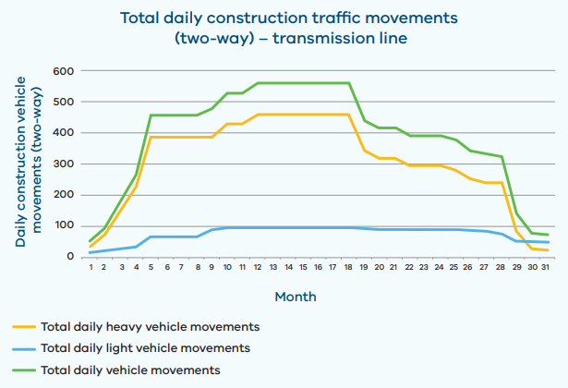
Figure 13: Transmission line construction traffic generation during construction phase
All EES documents, chapters, technical appendices and attachments are available to view and download on the VNI West website at vniwproject.com.au/EES
EES Chapter 18 and Technical Appendix K outline the transport needs of the project, including the use of arterial and low-volume local roads for construction activities along the length of the Proposed Easement.

Aviation
Eight certified aerodromes were identified within 30 nautical miles of the Proposed Easement. The assessment found that the Project would not infringe protected surfaces at these aerodromes, with the exception of Kerang Aerodrome, located approximately 5.4 km from the Proposed Easement. At this location, potential interaction relates to PANS OPS instrument procedure surfaces. During construction, temporary use of cranes and other tall plant may intrude into these surfaces. These impacts would be short term and managed through established aviation procedures, including advance notification to aerodrome operators and the use of Notices to Airmen (NOTAMs), enabling aircraft to avoid temporary hazards safely.
During operation, permanent transmission infrastructure has the potential to interact with PANS-OPS protected surfaces at Kerang Aerodrome depending on final design outcomes. These impacts would be avoided through detailed design measures, which may include relocation or adjustment of tower locations or heights, refinement of instrument procedures in consultation with aviation stakeholders, or selection of the Tragowel east Proposed Easement option. With these measures implemented, operational impacts at Kerang Aerodrome are expected to be avoided, resulting in low residual impact.
Seven uncertified airstrips were identified within 3 nautical miles of the Proposed Easement. Of these, Heifer Station Creek and Morrl Morrl airstrips are located in close proximity to the Proposed Easement and may be affected by both construction and operational permanent infrastructure. The primary impacts relate to reduced clearance for safe approach and departure paths. Ongoing consultation with landholders is being undertaken to determine mutually acceptable outcomes, which may include relocation or reorientation of airstrips or the installation of aviation warning markers on transmission infrastructure. Where agreement cannot be reached, residual impacts may be significant for affected operators and will be managed through the land acquisition and compensation framework.
The construction phase may also result in temporary aviation interactions associated with cranes, tall plant exceeding final tower heights, and possible helicopter use. These impacts would be managed through standard aviation safety controls, including notification procedures, stakeholder coordination, and temporary hazard management measures.
Overall, with implementation of PANS-OPS compliant design controls, consultation with aviation stakeholders, and established construction and operational aviation procedures, residual impacts to aviation safety are expected to be low across most of the Project area.
All EES documents, chapters, technical appendices and attachments are available to view and download on the VNI West website at vniwproject.com.au/EES
EES Chapter 21 and Technical Appendix N assess the potential effects on aerial safety, with particular consideration of certified aerodromes, agricultural aviation activities, emergency service, and rural airstrip operations. The assessment considered construction, operation and decommissioning phases in accordance with Civil Aviation Safety Regulations 1998 (CASR) and International Civil Aviation Organisation’s Procedures for Air Navigation Services Aircraft Operations (PANS-OPS).

Decommissioning
Following the operation phase of the Project, the transmission line and supporting infrastructure such as the terminal station would be decommissioned.
Decommissioning would involve lowering of overhead conductors and ground wires, removing insulators and line hardware and dismantling towers. It is expected that all tower footings would be excavated and demolished to at least 600 mm below ground level and then backfilled with suitable material. The decommissioning of the terminal stations will require the dismantling of all above ground structures, removal of footings and backfilling of the area. All waste would be managed in accordance with the relevant legislative requirements and industry standards.
The Project’s technical reports considered the potential impacts from decommissioning activities and found the activities would be similar to those required for construction of the Project, therefore the impacts to values would also be similar.
EPRs proposed for impacts in the construction and operation phases of the Project would also be applicable in the decommissioning phase, in accordance with the regulations of the time. However, due to the long lifespan of the Project current standards and approaches may no longer apply. The decommissioning stage of the Project would therefore be managed in accordance with a Project Decommissioning Environmental Management Plan, as required by the Project Environmental Management Framework (refer to EES Chapter 28: Environmental Management Framework), that would determine how to best avoid, manage or mitigate impacts at that time.
Once the facilities are demolished, the surrounding areas would be rehabilitated in accordance with the relevant legislative requirements and industry standards.

Cumulative impacts
Cumulative impacts may occur where incremental, successive and combined effects of actions or projects are added to other proposed actions or projects. Cumulative impacts were identified and assessed across all technical studies, with the key potential cumulative impacts relating to ecology, landscape and visual and Aboriginal cultural heritage.
Cumulative impact on biodiversity and habitat was estimated where data was available on nearby projects, noting that cumulative impact totals would be an underestimation of the true impact because data specific to many identified projects were unavailable. Considering the assumed VNI West Project losses, the total cumulative loss of native vegetation could be 2,104 ha. The Project’s contribution to this total loss (approximately 116 ha) is approximately 6% and considered as a minor contribution to the cumulative impact on native vegetation. The calculated cumulative impact on large trees from the projects considered in the assessment is 4,754 large trees in patches and 730 large, scattered trees. The Project will contribute to 10% of this overall loss.
For landscape and visual values, persons travelling along roads around Meering West, Normanville and Dingwall in the northern section of the study area, and around Joel Joel in the southern section may be subject to generally moderate levels of cumulative visual impact, at locations where proposed infrastructure from only one project is visible. In some instances, higher cumulative visual impacts may be perceived where views are affected by proposed infrastructure from this Project together with other proposed projects (e.g. transmission lines and wind turbines).
Private receptors with dwellings within 500 m of the Proposed Easement and infrastructure from other projects may be subject to moderate levels of cumulative visual impact at a minimum, and typically high cumulative impacts where minimal existing vegetation is available for screening of views.
The most profound cumulative impact to Aboriginal cultural heritage values in the region would be visual impact. The erection of several large-scale wind farms, as well as associated transmission infrastructure, would fundamentally change views across Country, and may change the sensory experience and context of existing significant Aboriginal places.
Taken together, the Project and other proposed projects would have at least a moderate cumulative impact on Aboriginal cultural heritage and Aboriginal cultural values in the region, particularly given the relatively low levels of infrastructure development in the region to date.
The Project’s contribution to potential cumulative impacts will be managed through relevant EPRs, with appropriate measures implemented to avoid, minimise and manage impacts and respond to unforeseen effects.

Proposed Easement options assessed in the EES
There are two locations along the Proposed Easement, at Tragowel and Teddywaddy, which have two Proposed Easement options proposed for assessment in the EES. These easement options have been retained in the EES so that further environmental studies could be undertaken to better inform the selection of the Proposed Easement at each location.
The comparative assessment of the easement options at both Tragowel and Teddywaddy indicates that the Proposed Easement options would result in broadly similar environmental, social and land use outcomes. Across most technical disciplines, the assessments concluded that there would be no material difference between the easement options at both locations. However, minor differences were identified across some disciplines, including ecology, cultural heritage, landscape and visual and agriculture in both areas. A material difference was identified in Tragowel in EES Chapter 21: Aviation, however impacts can be mitigated by amendments to flight procedures subject to approvals and review by the Civil Aviation Safety Authority.
Overall, the comparative assessment identified a marginal preference for the Tragowel western easement option and the Teddywaddy western easement option. While surveys are required to be conducted to confirm ground conditions, particularly in the Teddywaddy area, it is expected that impacts can be mitigated by the implementation of no-go zones or micro-siting of towers.

Key residual uncertainties
While a number of key uncertainties remain for the Project that have the potential to influence its impacts and outcomes, land access limitations during preparation of the EES are considered the primary uncertainty related to the assessment of impacts in the EES.
Land access limitations across the Project have meant that a limited portion of the Proposed Easement has been subject to field assessment to date, restricting the ability to quantify some impacts using survey based methods. To account for this, the EES intentionally adopts a conservative (worst case) estimation of impacts for studies that rely heavily on the results of field surveys, including ecology and Aboriginal cultural heritage. Areas that were unable to be accessed have been supported by a range of desktop and modelling methods, including predictive modelling for cultural heritage and an assumed presence approach for ecology. It is considered that due to this worst-case approach, the overall extent of impacts would intentionally be very conservative to avoid understating potential effects.
The characterisation of the Project’s potential impacts would be progressively refined as further land access is obtained and detailed design advances, with residual impacts managed through measures such as micro-siting and the application of an unexpected finds protocol. These measures would support the ongoing avoidance and minimisation of impacts and enable the Project’s environmental outcomes to be optimised to the extent practicable.

Environmental Management Framework
The Project’s Environmental Management Framework is a transparent governance framework with clear accountabilities for complying with approvals and for managing, monitoring and reporting on the environmental effects and risks of the Project across all phases. Consistent with the Scoping Requirements, the Environmental Management Framework also establishes the basis for the subsequent development, approval, implementation and review of environmental management plans (including consultation requirements), and links environmental performance to baseline conditions, monitoring and continuous improvement.
It also consolidates all the EPRs proposed to avoid, minimise, or manage potential adverse environmental effects and identifies the relevant statutory approval and conditions through which the EPRs will be implemented and enforced. The Environmental Management Framework and EPRs have been informed by the technical studies completed as part of the EES.
Following the Minister for Planning’s assessment of the EES, the EMF will be updated to address matters, conditions and recommendations from the assessment. A requirement to implement the EMF is included as a proposed condition of the Incorporated Document of the PSA, exhibited concurrently with the EES. If approved, the EMF and EPRs will have statutory effect and be enforceable under the P&E Act.
VicGrid VNI West, together with its Delivery Partner and contractors, will implement the EMF through EPRs, statutory approvals and consents, and phase-specific environmental management plans (CEMP, OEMP, DEMP). Legally binding contracts will require contractor compliance with the EMF, approvals, and relevant management plans.
VicGrid VNI West will also engage an Independent Environmental Auditor to review key documentation prior to works commencing and to audit environmental performance during delivery, with findings used to drive corrective actions and continuous improvement across the Project lifecycle.
The governance framework for construction is shown in Figure 14.
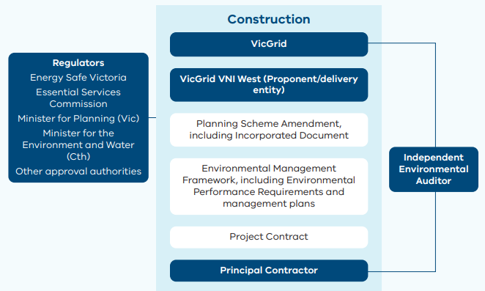
Figure 14: Governance framework for construction
Environmental management of the Project would be governed by the Incorporated Document forming part of the draft PSA. The Incorporated Document would be inserted into Clause 45.12 (Specific Controls Overlay) and Clause 72.04 (Incorporated Documents) of the Gannawarra, Buloke, Loddon and Northern Grampians Planning Schemes.
The purpose of the Incorporated Document is to permit the use and development of the Project Land for utility installations and accommodation and associated buildings and works and removal of native vegetation, in accordance with the Detailed Development Documents and conditions of the Incorporated Document. Read more: Attachment I: Draft Planning Scheme Amendment
The Incorporated Document establishes the statutory framework for the preparation, endorsement and implementation of key environmental management documentation prior to the commencement of development (or relevant stages or components). If approved following Minister’s assessment, the Incorporated Document would have statutory effect under the P&E Act and must be complied with during Project implementation.
Together, the Incorporated Document and the EMF establish a clear hierarchy of environmental controls that applies across design, construction, operation and decommissioning. Where inconsistencies arise between the EMF and a statutory approval or condition of approval, the statutory approval prevails to the extent of the inconsistency.
Figure 15 illustrates this hierarchy, distinguishing between:
- Level 1: Statutory documents endorsed or accepted under the Incorporated Document
- Level 2: The EMS and phase-based management plans required by the EMF
- Level 3: Management plans and property management plans and procedures required by EPRs

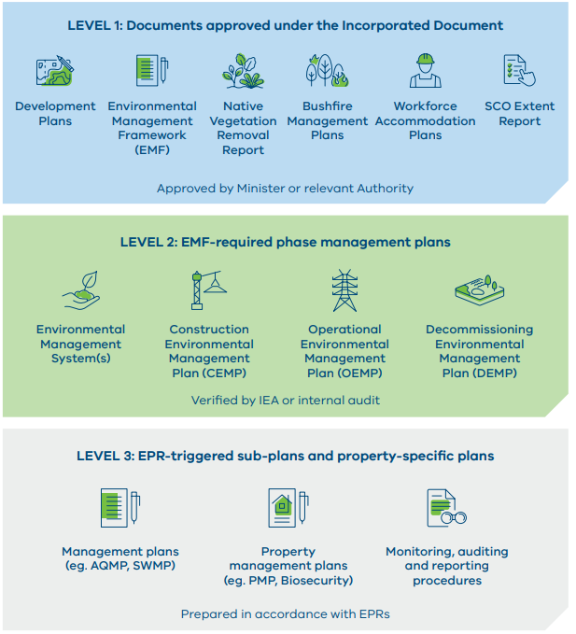
Figure 15: Hierarchy of environmental management documentation for the Project

Next steps
The proposed timeline for the planning, approvals, design, construction, and operation of the Project is shown in Figure 16. This timeline is indicative and subject to completion of the EES process, receipt of statutory approvals, procurement and commercial processes, and subsequent detailed design and delivery planning.
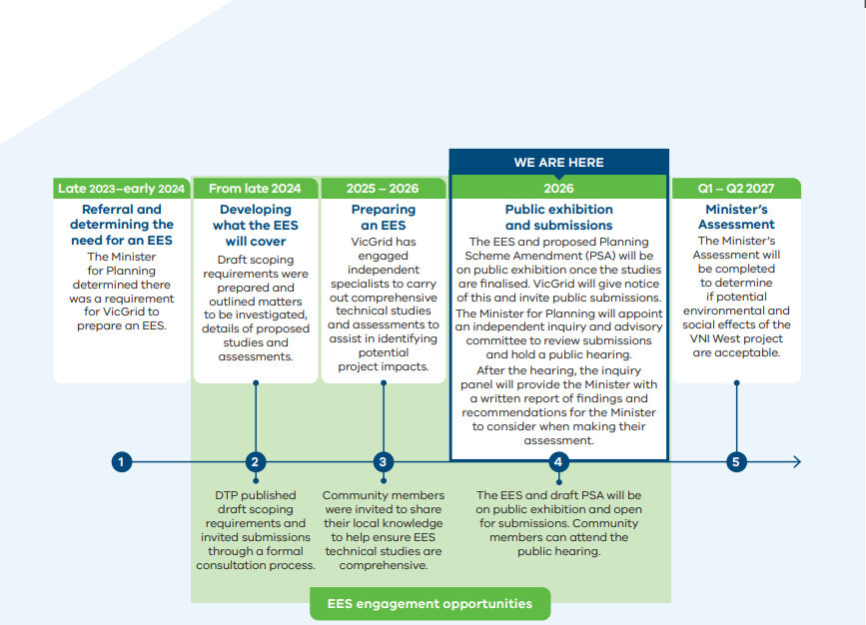
Figure 16: Indicative Project timeline

Public review of the EES
The EES main report, including technical appendices and attachments, including the draft PSA (GC316) will be placed on public exhibition on the Project’s website.
During the 30-business day exhibition period, members of the public, stakeholders and other interested parties will be able to view the EES and draft PSA GC316 and make written submissions on the Project and its assessed environmental effects on the Victorian Government’s online consultation platform Engage Victoria.
The EES and draft PSA are available to read and download on the VNI West website at vniwproject.com.au/EES
Please also check the Project website for updates and viewing locations: vniwproject.com.au
You can request an EES and PSA information pack, free of charge. The pack contains:
- EES Executive summary: A plain-English summary of the EES describing the process, scope, project overview and individual chapters (this document)
- USB drive: Containing the complete EES documents including EES main report, technical appendices, and the draft PSA
- Non-technical summary: A printed brochure providing an overview of the Project and the EES process
- Overview map: Printed overview map of the Project
- Guide/information sheet: A guide on how to navigate the EES and the submission process
An EES and draft PSA information pack can be requested by phoning 1800 824 221 or emailing enquiries@vniwproject.com.au
During the public exhibition period, a hard copy of EES documentation will also be available to view at the following Project offices and locations:
- VNI West Kerang regional office Shop 15, 47 Victoria Street, Patchell Plaza, Kerang
- VNI West Stawell regional office 179 Main Street, Stawell
- State Library Victoria 328 Swanston Street, Melbourne
Please note, the EES is made up of many large documents, and we encourage the use of electronic versions where possible.

Making a submission
Anyone can make a submission on the EES and the draft PSA. Submissions must be made in writing and be received by 11:59 pm on Monday 16 November 2026.
Submissions can be lodged via the online form on the Victorian Government’s Engage Victoria website: engage.vic.gov.au/VNI-West-IAC
Only one submission is needed to address all your views about the Project, its effects, and the relevant documents.
If you do not have internet access or are unable to lodge a submission online, contact Planning Panels Victoria (PPV) on 136 186 (select option 6) and request a hard copy submission coversheet. Each hard copy submission must be accompanied by a completed coversheet issued by PPV.
Submissions will be treated as public documents and will be published on the Engage Victoria website.
The submission process is independently managed by PPV and any enquiries regarding the management of submissions, or the Inquiry and Advisory Committee and hearing process should be directed to PPV.

The Inquiry and Advisory Committee process
The Minister for Planning will appoint an independent Inquiry and Advisory Committee (IAC) to consider the EES, draft PSA GC316 and received submissions. The scope of the IAC is limited to providing advice on the identified ‘key environmental matters’ and ‘other environmental matters’ outlined in the IAC Terms of Reference issued by the Minister for Planning.
The IAC will conduct a public hearing on the ‘key environmental matters’, which will commence in the week beginning Monday 8 February 2027.
The ‘other environmental matters’ will be considered by the IAC on the basis of written submissions only, as outlined in the Terms of Reference.
The IAC will hold a Directions Hearing on Monday 7 December 2026 to consider the arrangements and timetable for the Hearing and the process for submitters who want to be heard or provide further written material on ‘other environmental matters’.
Information on the IAC process will be published as it becomes available at: engage.vic.gov.au/VNI-West-IAC
The IAC will review all submissions, the EES and draft PSA before providing advice to the Minister for Planning about the Project in accordance with its Terms of Reference.
In relation to making a submission or the IAC process, contact:
Planning Panels Victoria
Phone: 136 186 (select option 6)
Email: office@planningpanels.vic.gov.au

Concluding the EES assessment process
Following the hearings, the IAC will provide a report to the Minister for Planning, who will consider this report to inform the Minister’s assessment of the Project’s environmental effects. The Minister’s assessment may conclude that the Project:
- Would have acceptable environmental effects, having regard to overall Project outcomes
- Would have unacceptable environmental effects
- Would need major modifications and/or further investigations to establish that acceptable environmental outcomes would be achieved
The Minister’s assessment will inform statutory decisionmakers responsible for issuing environmental approvals for the Project.

©VicGrid VNI West Pty Ltd, 2026. Copyright in this document is owned by VicGrid VNI West Pty Ltd, except where otherwise indicated.
No part may be reproduced, used, copied, published or adapted for use except in accordance with the provisions of the Copyright Act 1968 or with the consent of VicGrid VNI West Pty Ltd.
Disclaimer: This document has been prepared by or on behalf of VicGrid VNI West Pty Ltd for the purposes of preparing an Environment Effects Statement in accordance with the Environment Effects Act 1978 (Vic).
It is not intended to be used for and should not be relied upon for any other purpose. VicGrid VNI West Pty Ltd has made reasonable effort to ensure the information in this document is accurate and current, but does not warrant, guarantee or make any representations regarding the currency, accuracy, correctness, reliability, usability, or any other aspect of the material. This document or the information in it may also be subsequently updated or amended.
VicGrid VNI West Pty Ltd and its related entity, VicGrid, and their respective officers, employees and contractors accept no liability or responsibility for, or in respect of, any use of, or reliance upon, this document by any third party. Any third party using and/ or relying upon this document accepts sole responsibility and all risk for using and/or relying on this document for any purpose and should seek independent advice where appropriate.
The complete EES, draft PSA and technical appendices are available to read and download on the VNI West website at vniwproject.com.au/EES
Stay connected
Email: enquiries@vniwproject.com.au
Free call: 1800 824 221
Website: www.vniwproject.com.au
Facebook: @VNIWest
If you need an interpreter, please call 131 450 (within Australia). If you are deaf and/or find hearing or speaking with people on the phone difficult, please contact the National Relay Service on voice relay number 1300 555 727, TTY number 133 677 or SMS relay number 0423 677 767.

Over the modelled period
Over the modelled period

