  - Community amenity – VNI West

Landscape and visual
Victorian legislation recognises the value of landscapes for their intrinsic qualities, for the quality of life and enjoyment of people, and for the economic benefits they bring. Understanding the visual character of these landscapes and their recognised scenic and landscape values helps to assess the severity of impacts resulting from the Project across parts of the region, particularly for receptors (e.g. residences) located near roads, private dwellings, and recreational areas.
The Project comprises seven landscape character areas (LCAs), described as areas of similar patterns or elements in the landscape such as landform, vegetation, waterbodies and land use. Each of these LCAs has a distinct, recognisable and consistent pattern of elements that occur in the landscape.
- LCA 1: Farmland – moderate to high landscape value
- LCA 2: Woody farmland – moderate landscape value
- LCA 3: Native bushland – high landscape value
- LCA 4: Recreational parkland – moderate landscape value
- LCA 5: Lakes, wetlands and swamps – high landscape value
- LCA 6: Riparian corridors – high landscape value
- LCA 7: Township – high landscape value
The Project has sought to avoid topographic high points, townships, parks, reserves, and other recreational or publicly used areas where practicable.
During construction, visual impacts would be temporary and primarily associated with laydown areas and worker accommodation sites. Moderate impacts are anticipated for public receptors travelling along roads adjacent to these areas. Screening vegetation is proposed around construction sites to reduce visibility, and with these measures in place, residual construction impacts are expected to be low.
Construction impacts at lookouts and areas located more than 5 km from the Proposed Easement are expected to be negligible, with minimal change to recreational views.
During operation, transmission infrastructure (towers and lines) would be visible from some roads and nearby private dwellings, with impacts varying depending on proximity and landscape context. Moderate to high impacts are anticipated where infrastructure is located close to or crosses major roads, including highways and arterial routes, and in locations subject to environmental significance overlays. These views are generally exposed and representative of wider landscape conditions, and mitigation is not proposed at most public road viewpoints; therefore, residual operational impacts in these areas would remain moderate to high.
Private dwellings located within 500 m of the Proposed Easement would experience moderate to high visual impacts during operation. Screening vegetation may be implemented subject to agreement with landholders, which would reduce residual impacts to low to moderate in many cases.
Designated lookouts within 5 km of the Proposed Easement would experience moderate operational impacts, while impacts at lookouts beyond 5 km would be negligible due to distance and exposure. Mitigation is not proposed at these locations, and residual impacts would remain unchanged.
Community gathering places would experience moderate operational impacts; however, with screening vegetation where appropriate, residual impacts would be reduced to low.
Locations identified as Areas of Cultural Heritage Sensitivity, informed by engagement with First Nations representatives and Cultural Values Assessments, have been further assessed in Technical Appendix J: Landscape and visual impact and Technical Appendix R: Aboriginal cultural heritage.
Overall, while the Project would introduce new and permanent infrastructure elements into the landscape, impacts would vary depending on proximity and viewing context. With implementation of Environmental Performance Requirements (EPRs) including screening vegetation and sensitive siting, residual visual impacts are generally expected to range from low to moderate across most locations, with higher impacts limited to areas immediately adjacent to the Proposed Easement.
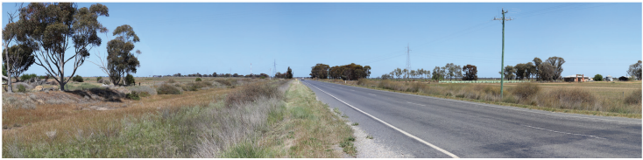
Example of view location in visual impact assessment – View location 19: Existing view
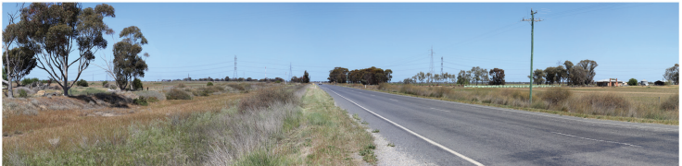
Example of view location in visual impact assessment – View location 19: Photomontage view, showing residual impact of ‘moderate’ for public receptors, and ‘high’ for private receptors
All EES documents, chapters, technical appendices and attachments are available to view and download on the VNI West website at vniwproject.com.au/EES
EES Chapter 17 and Technical Appendix J outline potential impacts from the Project to the character, scenic quality and visual amenity of the landscape, including the way it is perceived and experienced by surrounding communities and visitors.
Read more: Chapter 17: Landscape and visual & Technical Appendix J: Landscape and visual

