  - Land use and socioeconomic – VNI West

Agriculture
Agriculture is the dominant land use across the Project, and farming in the Project region (Gannawarra, Loddon, Buloke, and Northern Grampians LGAs) contributes more than 10% of Victoria’s total value of cropping, grazing, and dairy production.
The map below shows the geographic distribution of agricultural activity along the Proposed Easement.
The Project has the potential to influence agricultural production and farm operation, primarily through temporary land occupation and disruption, isolation of productive land (including irrigated areas), operational inefficiency around towers from movement of personnel and equipment.
The Project has sought to avoid areas of known agricultural infrastructure, including irrigation systems and areas of high-intensity agricultural activity such as horticulture and piggeries. Project design has incorporated advice from agricultural technical specialists to minimise impacts through the siting and design of transmission towers.
Construction of the Project would result in temporary disruption to agricultural activities on properties along the Proposed Easement over the approximately 3.5-year construction period. These disruptions would be intermittent and generally short in duration at the individual property level (typically days to weeks), although a broader area of approximately 3,551 ha may be affected at different times during construction. Most land would return to productive use once construction is complete.
The direct economic impact associated with the temporary loss of productive agricultural land during construction is estimated at approximately $2.77 million, representing around 0.3% of the total annual agricultural production value across the four Local Government Areas intersected by the Project. While this represents a minor impact at a regional scale, individual landholders may experience more noticeable effects, including disruption to farm operations, soil disturbance and potential biosecurity impacts.
The direct economic impact associated with the temporary loss of productive agricultural land during construction is estimated at approximately $2.77 million, representing around 0.3% of the total annual agricultural production value across the four LGAs intersected by the Project. While this represents a minor impact at a regional scale, individual landholders may experience more noticeable effects, including disruption to farm operations, soil disturbance and potential biosecurity impacts.
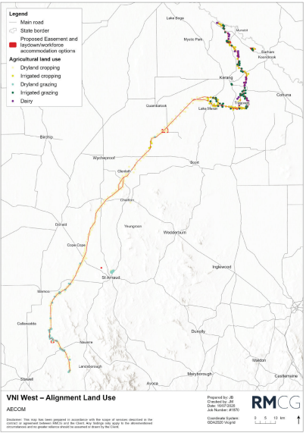
Geographic distribution of agricultural activity in the Project area
All EES documents, chapters, technical appendices and attachments are available to view and download on the VNI West website at vniwproject.com.au/EES
EES Chapter 20 and Technical Appendix M outline the Project’s potential to influence agricultural production and farm operations and consider how disruptions to farmers can be minimised.
Read more: Chapter 20: Agriculture & Technical Appendix M: Agriculture

