Environment Effects Statement Non-technical summary

About this summary
This document provides an overview of the Environment Effects Statement (EES) for the Victoria to New South Wales Interconnector West (VNI West) Project – Victorian component (the Project). It is intended to help readers understand the Project, the EES process, and how to access the full EES documentation and make a submission.
This summary is not a substitute for the EES. The full EES main report, technical appendices and supporting documentation contain the detailed information used to assess the Project’s environmental effects. This summary is intended to orient readers, explain the EES process and point to where more detailed information can be found in the EES.
The complete EES, draft PSA and technical appendices are available on the VNI West website at vniwproject.com.au/EES

Acknowledgement of Country
VicGrid proudly acknowledges the Traditional Owners of the lands on which VNI West is to be delivered, including those recognised through Native Title and those recognised by the State of Victoria as Registered Aboriginal Parties. We pay our respects to their Elders past and present.
VicGrid also acknowledges other First Peoples who maintain cultural connections, custodial responsibilities, and ongoing relationships to the lands and waters across the project area. We recognise their deep connection to Country and the significant role they play in caring for and managing land, water, natural and built landscapes, and in maintaining profound knowledge systems.
We remain committed to building genuine and enduring partnerships with First Peoples, grounded in respect, transparency, and cultural authority, to ensure that the planning and delivery of this project reflects their rights, culture, and connections to Country.

What is VNI West?
VNI West is a proposed new high-voltage electricity transmission project between Victoria and New South Wales. The broader VNI West project would connect Bulgana in western Victoria to Dinawan in New South Wales. The EES assesses the Victorian component of that broader project.
The Project assessed in the EES is approximately 240 km of 500 kV double-circuit overhead transmission and supporting infrastructure. The Project extends from Bulgana in western Victoria, where it would connect to the proposed Western Renewables Link, up to the Murray River north of Kerang, where it would connect to the New South Wales component of VNI West at the high-water mark on the Victorian side of the river. The Project includes a new terminal station at Tragowel, a new Bulgana Reactor Station, associated network connection works, workforce accommodation and laydown area options, and other temporary and permanent works needed for construction, operation and maintenance.
The proponent for the Project is VicGrid VNI West Pty Ltd (VicGrid VNI West). The Project would be developed by VicGrid VNI West with support from a Development Partner. Subject to approvals and procurement, project delivery would then proceed through a delivery arrangement consistent with the environmental management framework assessed through the EES.
The Project is located in western and north-west Victoria and passes through the Northern Grampians, Buloke, Loddon and Gannawarra local government areas.
Read more: Chapter 1: Introduction & Chapter 4: Project description
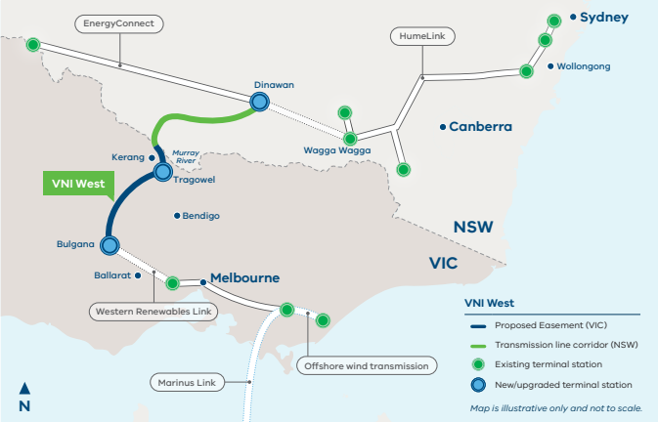

Location of VNI West across Victoria and NSW
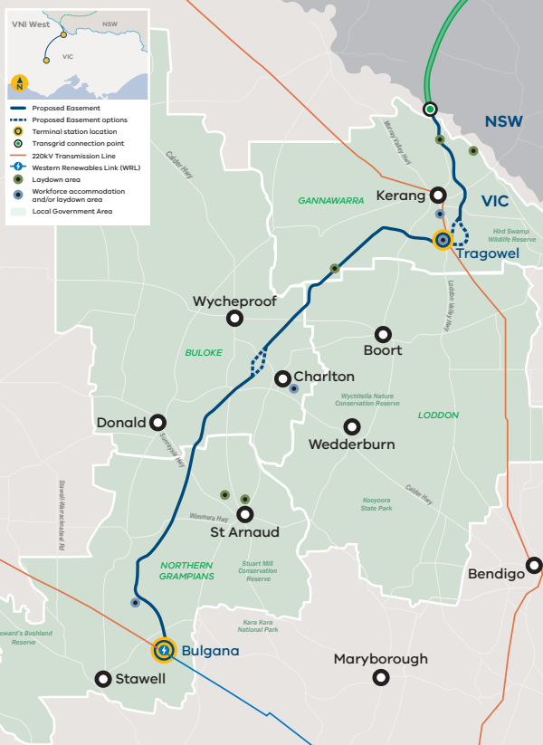

Why is the Project proposed?
Victoria’s and the broader National Electricity Market’s electricity systems are changing. A growing share of electricity is expected to come from renewable generation, storage and stronger transmission connections between regions, while coal-fired generation retires. In this context, additional transmission infrastructure is needed to connect new generation, support the transfer of electricity between regions, and help maintain secure and reliable electricity supply.
The Project is proposed to strengthen interconnection between Victoria and New South Wales, improve access to renewable electricity and storage, and support a secure and reliable electricity supply for Victorians during the energy transition. It is also intended to help connect renewable energy zones in Victoria and New South Wales and reduce network constraints that can limit how efficiently renewable electricity is used.
Existing transmission infrastructure was not designed for a system in which electricity comes from wind, solar and storage in different parts of the country. The Project is proposed as part of the broader changes needed to support that transition in Victoria and the wider National Electricity Market.
- Connect energy from renewable energy zones
- Strengthen the electricity connection between Victoria and New South Wales
- Help keep electricity supply reliable as coal-fired power stations retire
Read more: Chapter 2: Project rationale

Why is an EES being prepared?
The Project was referred to the Victorian Minister for Planning under the Environment Effects Act 1978 (EE Act). In April 2024, the Minister decided that an EES was required because the Project has the potential for a range of significant environmental effects.
The matters identified for assessment included potential effects on biodiversity, surface water and groundwater, Aboriginal cultural heritage, agriculture, landscape values, amenity and social and economic values.
The EES is the main environmental assessment document for the Project. It describes the Project, identifies its potential environmental effects, and sets out the framework proposed to avoid, minimise and manage those effects if the Project proceeds. The EES is not an approval in itself. It provides information for the Minister for Planning to assess the Project’s environmental effects and for statutory decision-makers to consider the approvals required if the Project proceeds.
In addition, the Project has also been determined to be a controlled action under the Environment Protection and Biodiversity Conservation Act 1999 (Cth) (EPBC Act) due to a range of significant environmental impacts. This means the Project also requires Commonwealth consideration, with the Victorian EES process being used to inform that decision under the bilateral assessment agreement between the Victorian Government and Commonwealth.

Project approvals
The Project is being assessed through an Environment Effects Statement (EES) administered by the Victorian Minister for Planning (the Minister) under the EE Act.
A number of key statutory approvals are required for the Project under Victorian and Commonwealth legislation. These include (but are not limited to):
- Approval of the controlled action under the EPBC Act (Commonwealth)
- Approval of several Cultural Heritage Management Plans (CHMPs) prepared in accordance with the requirements of the Aboriginal Heritage Act 2006 (Vic) (AH Act) and Aboriginal Heritage Regulations 2018
- Planning Scheme Amendment (PSA) GC316 to the Gannawarra, Loddon, Buloke and Northern Grampians planning schemes under the Planning and Environment Act 1987 (Vic) (P&E Act)
The principal environmental approval required under Commonwealth legislation is assessment and approval under the EPBC Act. Under the Bilateral Assessment Agreement between the Victorian and Commonwealth Governments, the EES serves as the accredited assessment process for the Project under the EPBC Act.
Several CHMPs are currently being prepared for the Project in consultation with the relevant Registered Aboriginal Parties (RAPs) and First Peoples – State Relations, these will be informed by the findings and risks identified as part of Technical Appendix R: Aboriginal cultural heritage and further investigations as required under the AH Act 2006. The CHMPs would be lodged for approval following the Minister’s assessment of the EES and are not publicly exhibited with the EES. Works for the Project cannot commence until the CHMPs have been approved as required by Section 49 of the AH Act.
Planning approval under the P&E Act will also be required for the Project. The preferred planning approval pathway is via a PSA, which provides an efficient and simplified approval process to allow the use and development of land for the Project. The PSA requires the preparation of an Environmental Management Framework (EMF) (see EES Chapter 28: Environmental Management Framework) which includes Environmental Performance Requirements (EPRs) applicable to the design, construction, operation and decommissioning of the Project.
Refer to EES Chapter 5: Legislative framework for further detail on the legislation and associated approval process requirements for the Project.
Read more: Chapter 1: Introduction, Chapter 5: Legislative framework & Chapter 28: Environmental Management Framework

Project EES timeline
- Project referred for assessment
- The Minister for Planning decided an EES was required
- The matters to be assessed in the EES were set
- The Project proponent prepared the EES
- The EES goes on public exhibition and submissions can be made
- The Minister for Planning appoints an Inquiry and Advisory Committee to review the EES, draft Planning Scheme Amendment and public submissions
- The Minister for Planning considers the EES and submissions
- Decision-makers then decide whether the Project can proceed

Key legislation and approval requirements
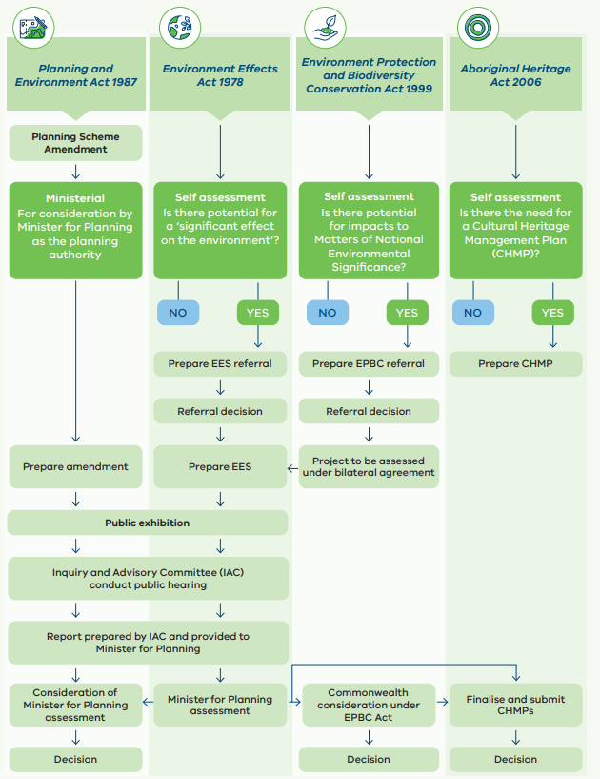

How the Project was developed
The Project assessed in the EES is the result of several years of investigation, engagement and refinement, rather than a fixed proposal developed in isolation. The Project has been progressively developed over several years through engineering design, environmental studies and engagement with landholders, Traditional Owners, community members, government agencies and other stakeholders.
The process began in 2019 with the commencement of the Australian Energy Market Operator’s (AEMO’s) Regulatory Investment Test for Transmission (RIT-T) process. This process identified a broad Area of Interest (also known as Option 5A) announced in May 2023. The Area of Interest was narrowed to a Draft Corridor in October 2023, following feedback and further technical, engineering and environmental assessment. The Proposed Easement was then identified in October 2024.
Throughout this process, and continuing through the EES process, the Project considered environmental, social, cultural heritage and engineering constraints, together with the network function the Project is intended to perform. The easement location was refined over time to ensure that the route could avoid and minimise impacts where practicable while maintaining a technically feasible and efficient project outcome. In some constrained areas, additional options were retained and assessed through the EES to support further consideration of environmental, social, land use, cultural heritage and engineering factors.
Other project elements were also assessed and refined during project development, including options for the Tragowel Terminal Station, workforce accommodation and laydown areas, and some construction and design choices.

Narrowing down the Project Area of Interest
Area of Interest (2019 - June 2023)
The Area of Interest was the broad starting area identified for the Project through earlier strategic planning. It provided the wider area within which route options could be investigated before more detailed refinement.
- 5,000+ properties
- Up to 50 km wide
Draft Corridor October 2023
The Draft Corridor is a refined study corridor developed from the broader Area of Interest through more detailed environmental, cultural heritage, agricultural, technical, engineering and planning assessments.
- 500+ properties
- Up to 2 km wide
Preferred Easement October 2024
The current preferred, approximately 70-metre-wide route for the proposed VNI West 500 kV transmission line in Victoria, identified through route refinement, technical studies and consultation as the least constrained location within, and in some locations adjacent to, the Draft Corridor.
- 221 properties
- ~70 m wide
Tower optimisation November 2024 – 2027
Tower optimisation refined proposed tower locations within the Preferred Easement responding to landholder feedback, property layouts, farming operations, technical requirements and environmental considerations.
Key considerations used to avoid and minimise impacts while narrowing the Area of Interest to the Proposed Easement
- Places of Aboriginal cultural significance
- Biodiversity and threatened habitat, including conservation and flora reserves
- Existing and future land use including agriculture and infrastructure requirements
- Proximity to dwellings, schools and hospitals
- Incompatible land uses such as transport networks, airfields and airports
- Geography and topography of the land, including terrain and waterbodies
- Overall length required for the transmission route and number of landholders impacted
- Reducing the number of transmission line angle deviations where possible
- Accessibility for renewable energy developers

What the Project includes
The EES identifies a proposed 70 metre easement for transmission. A broader project area has also been assessed to allow for some adjustment to final tower siting, detailed design refinement, or changes to address recommendations resulting from the EES process, while keeping those later decisions within the framework assessed through the EES. In two locations, a wider easement is required, these are transposition locations which are 170 m wide.
The main components of the Project are:
- Approximately 240 kilometres of new overhead 500 kV double-circuit transmission line
- Transmission towers generally between 60 and 80 metres high on average every 400-550 m
- A new terminal station at Tragowel with 500 kV and 220 kV equipment/interface
- Modifications to the existing 220 kV transmission line between Kerang and Bendigo at the proposed Tragowel Terminal Station
- Two sets of 500 kV shunt reactors at Bulgana, adjacent to or within WRL’s proposed Bulgana Terminal Station
- Nine laydown and/or workforce accommodation options
- The key components of the VNI West Project in both Victoria and NSW are shown below.
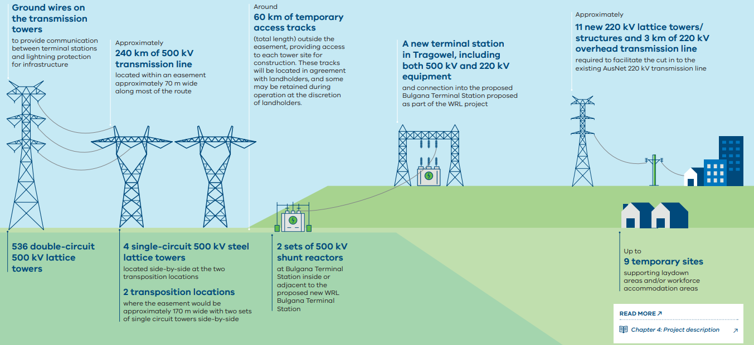

What the EES investigates
The EES investigates the Project’s potential effects during construction, operation and, where relevant, decommissioning. It looks at the matters identified in the Scoping Requirements and other significant issues identified through technical studies and engagement. These matters include biodiversity, water, farming and land use, Aboriginal cultural heritage, historic heritage, landscape and visual effects, traffic, noise, community and social effects, bushfire risk, climate change, and other environmental and planning matters.
Nineteen specialist technical studies were undertaken to support the assessment of environmental effects presented in the VNI West EES main report. Their findings are provided in the relevant EES chapters and in detail in the supporting technical appendices. Together, these studies assess the Project’s likely environmental effects and provide the basis for the conclusions presented in the EES.
The Scoping Requirements establish the matters to be investigated for the EES. These matters reflect the decision and priorities identified by the Minister for Planning regarding the need for an EES. The EES has been prepared in accordance with the final Scoping Requirements.
- Air quality Dust, emissions and air quality
- Aviation Aircraft operations and airspace
- Aboriginal cultural heritage Places of cultural significance and values
- Agriculture Farms, farming and agricultural land
- Bushfire Fire risk and emergency management
- Business and economics Jobs, businesses and the local economy
- Climate change Climate risks and resilience
- Ecology Plants, animals and habitats
- Electric and magnetic field Electric fields, magnetic fields and interference
- Geology and soils Geology, soils, and contaminated land
- Greenhouse gas Emissions and carbon impacts
- Groundwater Aquifers, bores and groundwater resources
- Historic heritage Historic places and heritage values
- Land use and planning Changes to how land is used
- Landscape and visual Views, landscape and visual character
- Noise and vibration Construction and operational noise
- Social Communities, wellbeing and social values
- Surface water Rivers, wetlands and flooding
- Traffic and transport Roads, traffic and access
Where to find more information: More detail on each topic is provided in EES Chapters 8 to 27 and the supporting Technical appendices A to S and Attachments I to VI. A high-level summary of key findings is also provided in the EES Executive summary.

The Environment Effects Statement documents
The VNI West Environment Effects Statement (EES) includes an executive summary, chapters, technical appendices and attachments, each offering varying detail for quick reference or in-depth review.
All EES documents, chapters, technical appendices and attachments are available to view and download on the VNI West website.
Executive summary
A plain-English overview of the project, its potential impacts and the proposed management measures.
EES main report
There are 29 chapters that provide an overview of the project rationale, legislative and approval requirements, assessment approach and the community and stakeholder engagement undertaken.
Chapters:
- Table of contents
- Glossary and abbreviations
- Ch. 1 Introduction
- Ch. 2 Project rationale
- Ch. 3 Project development and alternatives
- Ch. 4 Project description
- Ch. 5 Legislative framework
- Ch. 6 Assessment framework
- Ch. 7 Stakeholder and community engagement
- Ch. 8 Electric and magnetic field
- Ch. 9 Geology and soils
- Ch. 10 Groundwater
- Ch. 11 Historic heritage
- Ch. 12 Bushfire
- Ch. 13 Climate change
- Ch. 14 Surface water
- Ch. 15 Greenhouse gas
- Ch. 16 Air quality
- Ch. 17 Landscape and visual
- Ch. 18 Traffic and transport
- Ch. 19 Noise and vibration
- Ch. 20 Agriculture
- Ch. 21 Aviation
- Ch. 22 Business and economics
- Ch. 23 Land use and planning
- Ch. 24 Social
- Ch. 25 Aboriginal cultural heritage
- Ch. 26 Ecology
- Ch. 27 Matters of National Environmental Significance
- Ch. 28 Environmental Management Framework
- Ch. 29 Conclusion
Technical appendices
Detailed technical studies that inform the EES
Appendices:
- Electric and magnetic field
- Geology and soils
- Groundwater
- Historic heritage
- Bushfire
- Climate change
- Surface water
- Greenhouse gas
- Air quality
- Landscape and visual
- Traffic and transport
- Noise and vibration
- Agriculture
- Aviation
- Business and economics
- Land use and planning
- Social
- Aboriginal cultural heritage
- Ecology
Attachments
- Draft Planning Scheme Amendment
- Stakeholder and community engagement report
- Draft Offset Strategy
- Map book
- Comparative assessment of overhead and underground transmission technologies
- Detailed project development and alternatives

Environmental management
The EES does not only identify the Project’s potential effects, it also sets out the framework proposed to manage those effects if the Project proceeds. This is done through the Environmental Management Framework (EMF) and Environmental Performance Requirements (EPRs), which are included in EES Chapter 28: Environmental Management Framework.
The EMF sets the overall environmental management framework for the Project. It identifies roles and responsibilities, the key documentation that would be required for later stages of the Project, and the basis for monitoring, auditing, compliance and reporting. The EPRs set the environmental outcomes that must be achieved during detailed design, construction, operation and, where relevant, decommissioning. Detailed management plans and procedures are also required to be prepared for all stages of the Project in accordance with the EMF and EPRs.
VicGrid VNI West would retain overall responsibility for the environmental framework for the Project. Delivery contractors would be required to comply with that framework if the Project proceeds.
Read more: Chapter 28: Environmental Management Framework

How environmental effects should be managed
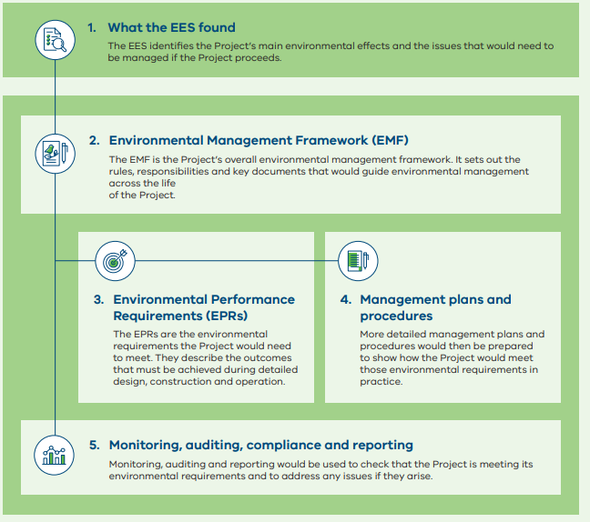

Who is responsible?
VicGrid VNI West
Overall responsibility for the Project’s environmental framework.
Delivery Partner/Principal Contractor
Responsible for following the EMF, EPRs and later management plans during delivery of the Project.
Transmission Network Service Provider or operator
Responsible during operation, where relevant, for following the environmental requirements that apply at that stage.

How to view the EES and make a submission
The EES main report, including technical appendices and attachments, including the draft PSA (GC316) will be placed on public exhibition on the Project’s website.
During the 30-business day exhibition period, members of the public, stakeholders and other interested parties will be able to view the EES and draft PSA (GC316) and make written submissions on the Project and its assessed environmental effects on the Victorian Government’s online consultation platform Engage Victoria.
The EES and draft PSA are available to read and download on the VNI West website at vniwproject.com.au/EES
Please also check the Project website for updates and viewing locations: vniwproject.com.au
You can request an EES and PSA information pack, free of charge. The pack contains:
- EES Executive summary: A plain-English summary of the EES describing the process, scope, project overview and individual chapters.
- USB drive: Containing the complete EES documents including EES main report, technical appendices, and the draft PSA.
- Non-technical summary: A printed brochure providing an overview of the Project and the EES process (this document).
- Overview map: Printed overview map of the Project
- Guide/information sheet: A guide on how to navigate the EES and the submission process.
An EES and draft PSA information pack can be requested by phoning 1800 824 221 or emailing enquiries@vniwproject.com.au
EES documentation will also be available to view at the following Project offices and locations:
- VNI West Kerang regional office Shop 15, 47 Victoria Street, Patchell Plaza, Kerang
- VNI West Stawell regional office 179 Main Street, Stawell
- State Library Victoria 328 Swanston Street, Melbourne
Please note, the EES is made up of many large documents, and we encourage the use of electronic versions where possible.

How to make a submission
Anyone can make a submission on the EES and draft PSA.
Submissions must be made in writing and be received by 11:59 pm on Monday 16 November 2026.
Submissions can be lodged via the online form on the Victorian Government’s Engage Victoria website: engage.vic.gov.au/VNI-West-IAC
Hard copy submissions
If you do not have internet access or are unable to lodge a submission online, contact Planning Panels Victoria (PPV) on 136 186 (select option 6) and request a hard copy submission coversheet.
For privacy reasons, hard copy submissions must be accompanied by a coversheet issued by PPV.
All submissions must state the name and address of the person making the submission.
Submissions will be treated as public documents and will be published on the Engage Victoria website.
More information
More information on how to make a submission, the submission process and public hearings can be found on the Engage Victoria website engage.vic.gov.au or by contacting PPV on 136 186 (select option 6).
The submission process is independently managed by PPV and any enquiries regarding the management of submissions, or the Inquiry and Advisory Committee and Hearing process should be directed to PPV.

What happens next?
The Minister for Planning will appoint an independent Inquiry and Advisory Committee (IAC) to consider the EES, draft PSA GC316 and received submissions. The scope of the IAC is limited to providing advice on the identified ‘key environmental matters’ and ‘other environmental matters’ outlined in the IAC Terms of Reference issued by the Minister for Planning.
The IAC will conduct a public hearing on the ‘key environmental matters’, which will commence in the week beginning Monday 8 February 2027.
The ‘other environmental matters’ will be considered by the IAC on the basis of written submissions only, as outlined in the Terms of Reference.
The IAC will hold a Directions Hearing on Monday 7 December 2026 to consider the arrangements and timetable for the Hearing and the process for submitters who want to be heard or provide further written material on ‘other environmental matters’.
If you would like to participate in the IAC process, by either appearing at the Hearing and/or providing further written information, you will need to make a written submission and mark on the submission form that you would like to participate.
In relation to making a submission or the IAC process, contact:
Planning Panels Victoria
Phone: 136 186 (select option 6)
Email: office@planningpanels.vic.gov.au
The IAC will review all submissions, the EES and draft PSA before providing advice to the Minister for Planning about the Project in accordance with its Terms of Reference.
The IAC will provide a report to the Minister for Planning, who will consider this report to inform the Minister’s assessment of the Project’s environmental effects. The Minister’s assessment of the Project will make recommendations about whether the environmental effects of the Project are acceptable and will inform statutory decision-makers responsible for issuing environmental approvals for the Project.
If the Project proceeds following the EES process, the next steps would include completion of the relevant statutory approvals, progression of detailed design, and implementation of the EMF and EPRs through later stages of the Project.

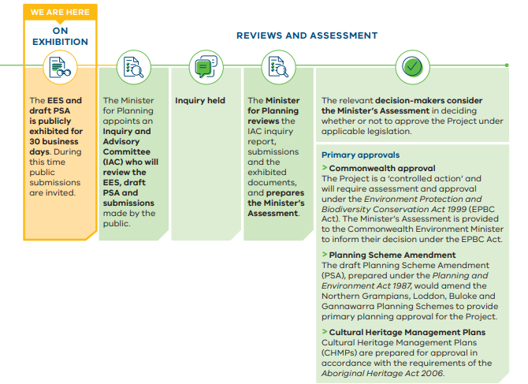

©VicGrid VNI West Pty Ltd, 2026. Copyright in this document is owned by VicGrid VNI West Pty Ltd, except where otherwise indicated.
No part may be reproduced, used, copied, published or adapted for use except in accordance with the provisions of the Copyright Act 1968 or with the consent of VicGrid VNI West Pty Ltd.
Disclaimer: This document has been prepared by or on behalf of VicGrid VNI West Pty Ltd for the purposes of preparing an Environment Effects Statement in accordance with the Environment Effects Act 1978 (Vic).
It is not intended to be used for and should not be relied upon for any other purpose. VicGrid VNI West Pty Ltd has made reasonable effort to ensure the information in this document is accurate and current, but does not warrant, guarantee or make any representations regarding the currency, accuracy, correctness, reliability, usability, or any other aspect of the material. This document or the information in it may also be subsequently updated or amended.
VicGrid VNI West Pty Ltd and its related entity, VicGrid, and their respective officers, employees and contractors accept no liability or responsibility for, or in respect of, any use of, or reliance upon, this document by any third party. Any third party using and/ or relying upon this document accepts sole responsibility and all risk for using and/or relying on this document for any purpose and should seek independent advice where appropriate.
The complete EES, draft PSA and technical appendices are available to read and download on the VNI West website at vniwproject.com.au/EES

